Table of contents:
‘Flawlessly Mood Enhancing’:
GERA Leuchten at the imm cologne Pages 2-5
GERA Light Shelf Pages 6-9
GERA Wall Shelf Pages 10-11
Pendulum Lamp GERA 40 x 10 LS 6 Page 12
GERA Standard Lamp Avion Page 13
Coat Rack Lamp GERA LS 8 Page 14
GERA Leuchten – the company Pages 15-16
Overview of the picture data Pages 17-18
The complete text & photo materials can be
found on the enclosed CD-ROM.
‘Flawlessly Mood Enhancing’: GERA Leuchten presents its illuminated furniture for atmospheric staging of rooms
Each room has a specific function and therefore requires its own respective mood. The atmospheric mood and the quality of the room is characterised by the interaction of materials, colours, surfaces and light. With its cutting-edge illuminated furniture, GERA Leuchten has managed to unite these design aspects in products of the highest standards of aesthetics. The company has absolutely perfected the art of transforming light in highly-functional and extraordinarily-aesthetic furniture. The result is illuminated furniture which – despite all its functionality – pursues a far more innovative furnishing philosophy: it illuminates, while being an adjustable source of light at the same time. And visitors to the imm cologne will be able to convince themselves of this between January 13 and 19, 2014.
With its trade fair motto ‘Flawlessly Mood Enhancing’, the company – at the Pure Village, Hall 2.2, Aisle O, Stand 039 – will be showcasing how its illuminated furniture, in the form of shelves, pendulum lamps and other systems, which are also convertible on request, provides complete room lighting concepts.
The core item of the trade fair presentation is the GERA Light Shelf. Uniting the functions of illuminating and load-bearing has created a dual interior design benefit that opens up entirely new design options. In addition to light, the timeless product design and the character of the materials used – aluminium, glass and wood – not only determine and define the impact and perception of the furniture, but also the entire room. As a result of its sleek, timeless and simultaneously flexible design, this furniture is perfect for hotels, law and medical practices, offices and shops – while also providing a highlight for design-conscious consumers.
The creative leeway and the planning freedom that GERA Leuchten – as a manufactory – offers are particularly impressive: virtually any constellation is possible in terms of the desired materials, the light temperature and the dimensions. As a result, the collaborative exchange with the customer generates an end product with a completely unique, stylish identity that is able to sensitively integrate itself into a room’s lighting concept, while simultaneously demonstrating its autonomy.
With its illuminated furniture, GERA Leuchten offers high-end, flexible furniture that can be precisely integrated into the most varied projects and customer requirements. “Our illuminated furniture is absolutely unique. We provide interior designers, planners and furniture providers with the ability to distinguish themselves from their competitors and to orient themselves on the needs of their customers in a variety of different ways. With the help of our illuminated furniture, they can now cater to customised design requests and successfully distinguish themselves from the mass”, comments Thomas Ritt, Designer and Product Manager at GERA Leuchten.
GERA Light Shelf
The exquisite GERA Light Shelf unites minimalist design with extraordinary functionality, stringently oriented on users’ requirements. The ScanAndLight function, which is integrated into the furniture and which measures and controls the light within the room and in each individual lamp, permits the user to control all the light in the room. Targeted microelectronic control of the LED colour components permits the creation of a constantly-adapting light mood throughout the entire room, which is perceived as being completely natural by the human eye.
The shelf is an impressive example of the unique radiance with which an integral lighting system is able to provide an item of furniture. Functionality and creative power ensure the GERA Light Shelf is far more than merely an item of furniture. Thomas Ritt describes it as “a timeless, refined and load-bearing shelving system that acquires its colour not through lacquer, but through light itself and which integrates itself into the room perfectly with its dramatic features.” In a nutshell: the shelf defines the light mood of the entire room, hence becoming the very heart of any lighting concept.
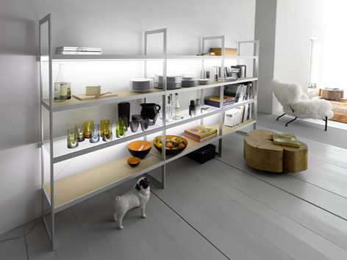
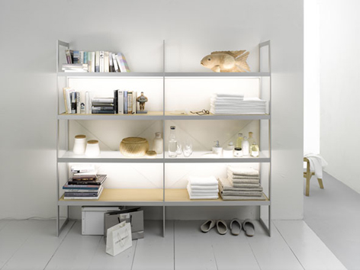
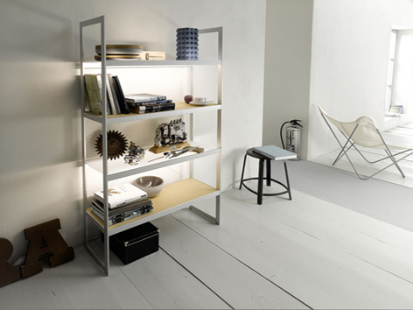
The GERA Light Shelf is 1840 mm high and 350 mm deep. It comes in three standard width variants: GERA Light Shelf 100, 200 and 300. As a single-width design, the GERA Light Shelf 100 is precisely 1000 mm in width. The double- and triple-width versions are 1990 mm and 2980 mm wide respectively.
While the GERA Light Shelf was available exclusively with glass shelves in the past, new designs now also include light oak, which place the focus more on cosy furniture design. Combined with the high-end, brushed aluminium frame, the two versions are characterised by formal stringency and design simplicity which perfectly integrate into virtually any environment. The GERA Light Shelf reveals its entire creative power particularly in smaller spaces. In open plan areas, the GERA Light Shelf is able to create stylish transitional areas that pick up on – and merge – the moods of the two distinct spaces. In this way, the shelf can be positioned on the way to the living or dining area, to the office, the bath or the sauna, hence creating a fluid transition to the respective area by dispensing with the objects generally required there. The load-bearing, illuminating function coupled with the sleek design lend the GERA Light Shelf an absolutely unique character which can provide frequently neglected transitional areas with new design impetus.
GERA Wall Shelf
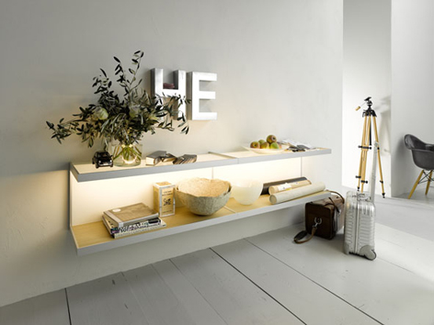
With the GERA Wall Shelf, clear functionality meets maximum staging impact. This furniture not only creates order, its radiant light also lends the surrounding space an elegantly-staged atmosphere. Equipped with the GERA ScanAndLight technology, this furniture harmoniously integrates into any light ambience or creates targeted light contrasts that define the character of the room and make the wall shelf almost appear to be a work of art.
The GERA Wall Shelf is available both with illuminated glass shelves or as a combination with wooden shelves in light oak. The height is 410 mm, the depth is 350 mm and the standard width is 1000 mm. Thanks to its special construction, two GERA Wall Shelfs can be easily mounted in close contact to each other, without leaving any space in between. In this case the width is 2000 mm. Thanks to its versatility, this minimalist and simultaneously mood-enhancing item of furniture can be used in the most diverse room situations.

Pendulum Lamp GERA 40 x 10 LS 6
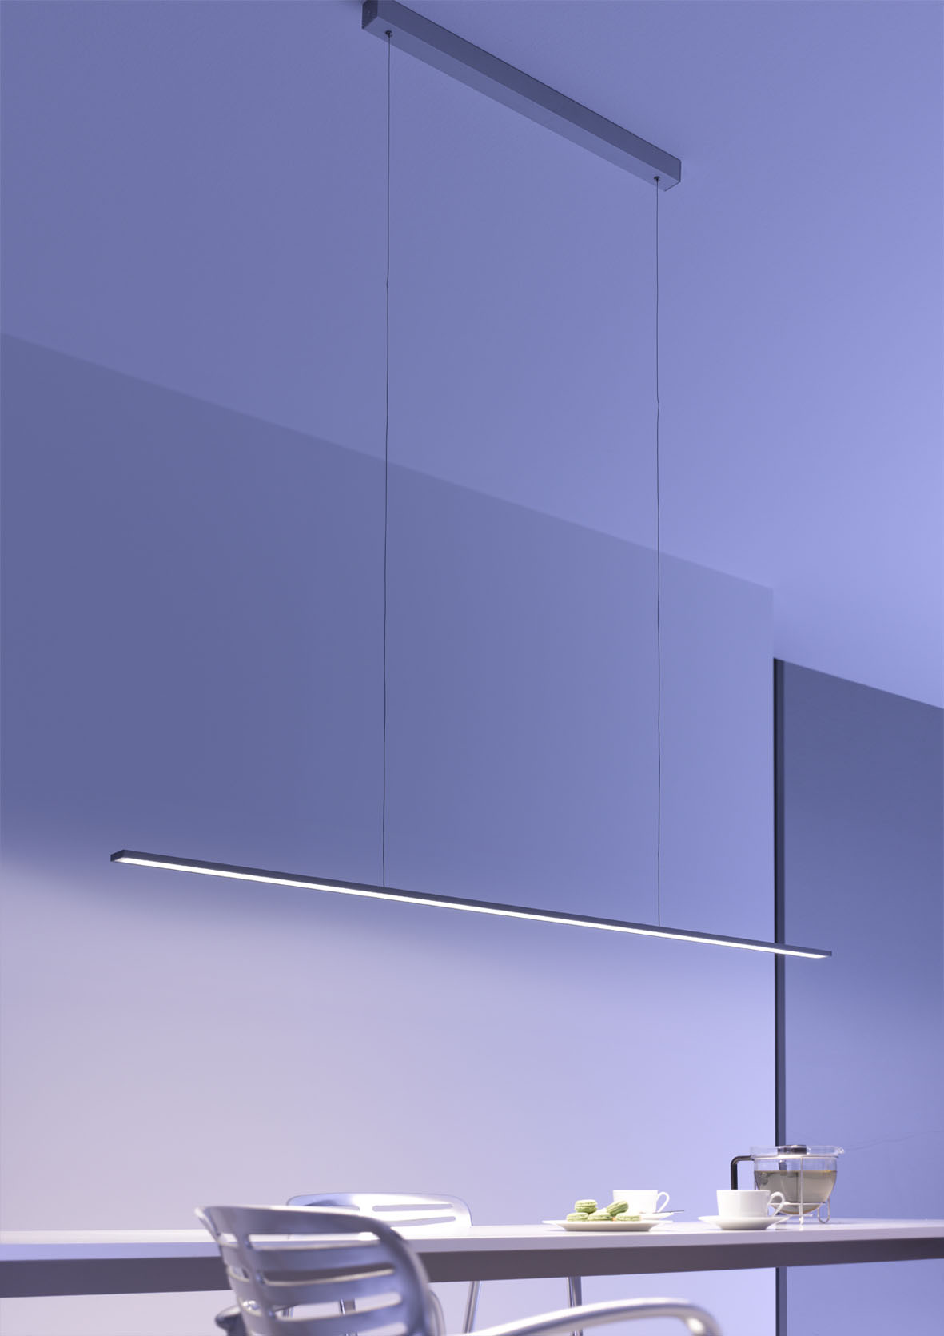
The elegant Pendulum Lamp GERA 40 x 10 LS 6 is a dream for all interior designers. With its extremely slim-line profile and the inconspicuous power supply thanks to the smallest conductor cross-sections, it appears to be virtually weightless and almost floating despite its impressive light emission. The option to customise both the length and the light temperature also provides total planning freedom and enables the lamp to be deployed as a pendant lamp above tables and counters, as a niche lamp in kitchens or as a mirror lamp in bathrooms.
GERA Standard Lamp Avion
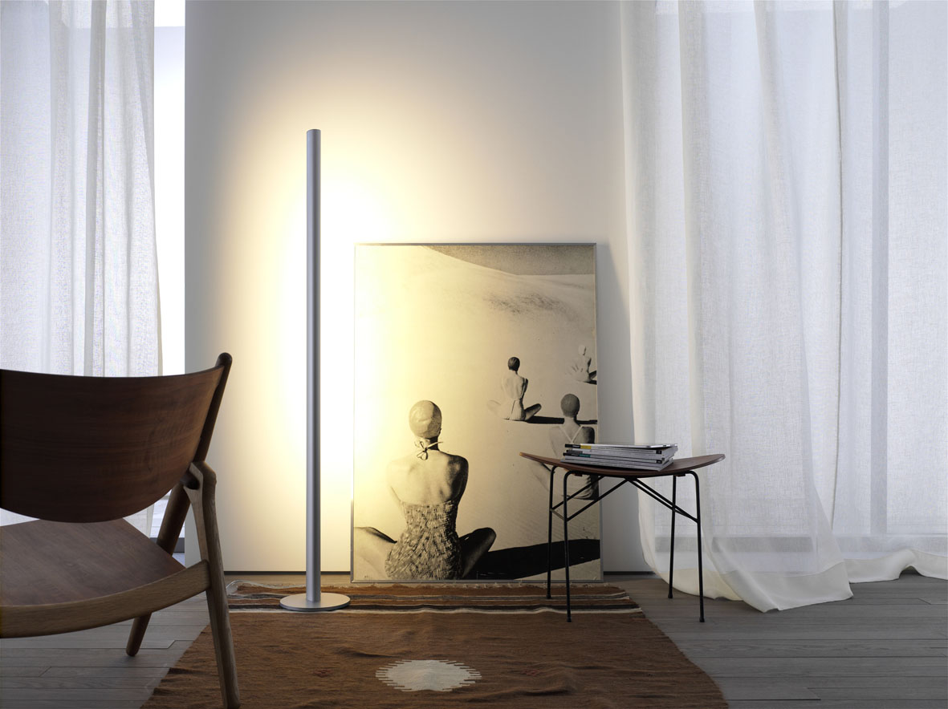
Thomas Ritt describes the design vocabulary of the product innovation from GERA Leuchten as follows: “The curved cross-section of the aluminium profile is reminiscent of the gentle shape of a bird or aeroplane wing”. Clean lines lend the design a timelessly-modern and extremely soothing radiance. The standard lamp is activated and dimmed contact-free and is available in white or in aluminium. And like all GERA lamps, it is perfectly suited for staging niches, corners or walls without placing itself centre-stage.
Coat Rack Lamp GERA LS 8
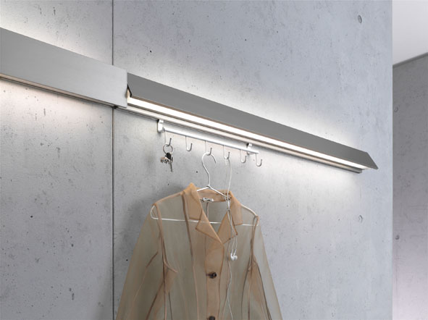
As in the case of all GERA Leuchten illuminated furniture, Coat Rack Lamp GERA LS 8 is an object that does more than just illuminate. The special feature of this architecturally-designed lamp is the option to insert one or more hook strips into a track concealed behind the lamp, permitting users to create a load-bearing coat rack, for example.
The product can be customised in terms of width and hence fills even smaller niches with sensible functions. In contrast, the addition of several lamps can result in interesting, linearly-aligned installation effects in longer corridors.
GERA Leuchten – the company
With its comprehensive knowledge of light design, furniture construction and electrical engineering, GERA Leuchten has also been developing its own furniture concepts, which – in combination with the corresponding lamps – are unique within the market.
With its characteristic illuminated furniture, the company has created a whole new product category, which always strives to create a double benefit by uniting the functions of illuminating and load-bearing. The design of the individual products is the result of the dimensional system of an overarching product family. Formal stringency, design simplicity, authenticity and logic come together in products whose style is characterised by timelessly-functional form.
Needless to say, all GERA products also comply with the very highest quality demands and carry the ‘Made in Germany’ seal of approval. This is guaranteed by the ISO-certified manufacturing process and the highly-qualified GERA employees.
Overview of the picture data

GERA_Lichtregal_100 GERA_Lichtregal_200

GERA_Lichtregal_300 GERA_Wandregal

GERA_Pendelleuchte_LS6

GERA_Stehleuchte_Avion GERA_Garderobenleuchte_LS8

