imm cologne 2014: extremely positive feedback for illuminated furniture
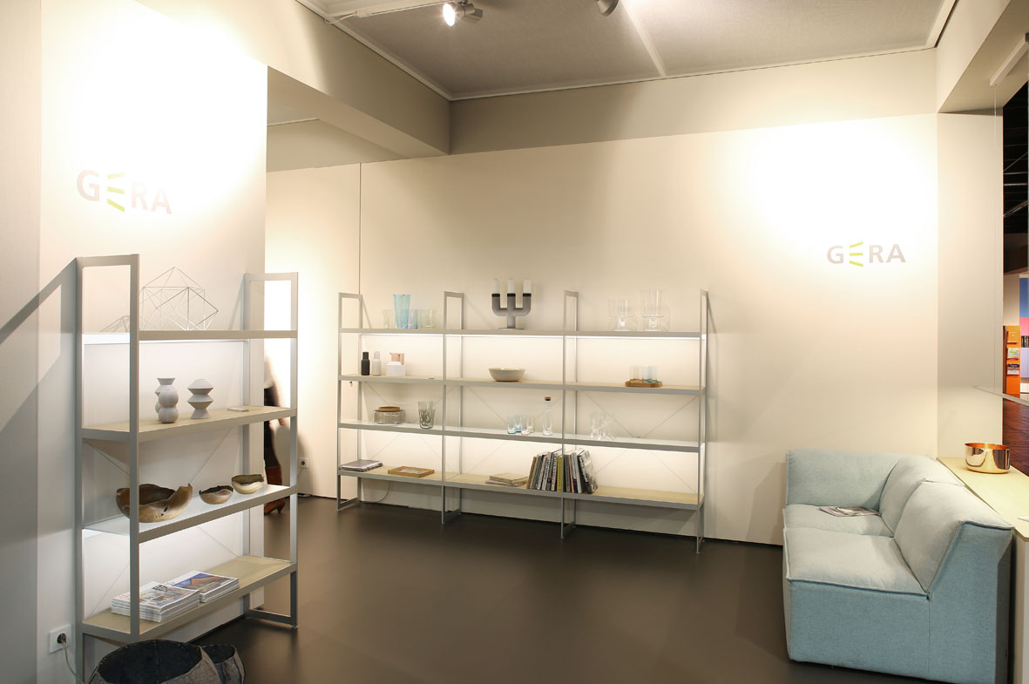
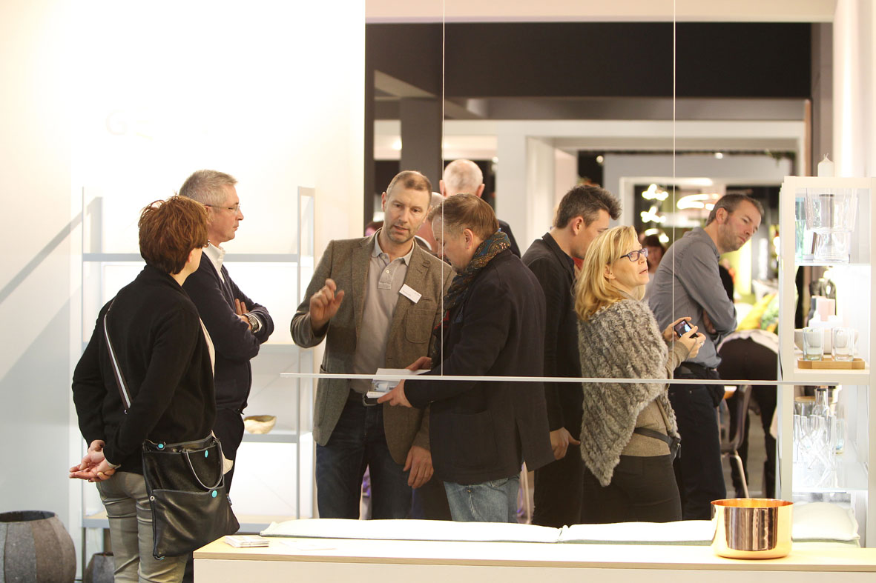
“For us, the imm cologne was a hugely successful event with which we are satisfied overall. Our products received extremely positive feedback both from the trade and consumers”, summarised Hening Pölitz, Managing Director of GERA Leuchten.
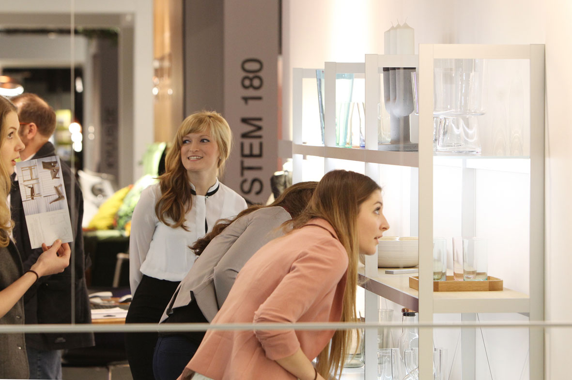
Exhibiting in Cologne between January 13 and 19, GERA Leuchten showcased – with its trade fair motto ‘Flawlessly Mood Enhancing’ – how its illuminated furniture, in the form of shelves, pendulum lamps and other systems, which are also convertible on request, provides complete room lighting concepts. In this form, the products are absolutely unique within the market – and hence extremely distinctive. The core item of the trade fair presentation was the GERA Light Shelf. Uniting the functions of illuminating and load-bearing has created a dual interior design benefit that opens up entirely new design options. In addition to light, the timeless product design and the character of the materials used – aluminium, glass and wood – not only determine and define the impact and perception of the furniture, but also the entire room. The Light Shelf acquires its colour not through lacquer, but through light itself, perfectly integrating itself into countless room concepts with its dramatic features. The possibility of controlling light colour and temperature was particularly appreciated by trade fair visitors. “The direct feedback has shown us that although consumers may still know very little about illuminated furniture and its impact on spaces and mood, they are nonetheless very open towards, and interested in, the topic of light, furniture and light control”, comments Hening Pölitz. And the furniture trade was both curious and enthusiastic with regards to illuminated furniture. GERA Leuchten provides furniture suppliers with the ability to distinguish themselves from their competitors and – thanks to the customisable items of furniture – allows them to target their offerings at the most diverse customer requirements. Customised design requests can be fulfilled with one and the same product: as a result of their sleek, timeless and simultaneously flexible design, the GERA Leuchten illuminated furniture is perfect both for equipping hotels, law and medical practices, offices and shops and for use in private households. An argument that also convinced the trade: numerous companies used the trade fair to directly place orders for illuminated furniture for their showrooms.

GERA Leuchten – the company
As a competent development partner and supplier for the entire interiors industry, the Thuringian company has long been a globally highly-coveted supplier brand. With its comprehensive knowledge of light design, furniture construction and electrical engineering, GERA Leuchten has also been developing its own furniture concepts for some time now, which – in combination with the corresponding lamps – are unique within the market.
And it goes without saying that all GERA products also comply with the highest quality standards. This is guaranteed by the ISO-certified manufacturing process and the highly-qualified GERA employees. All GERA lighting systems carry the ‘Made in Germany’ seal of approval.
Overview of the picture data

GERA_imm_1 GERA_imm_2

GERA_imm_3

