Lightbodies of the future: design students develop visionary lighting concepts
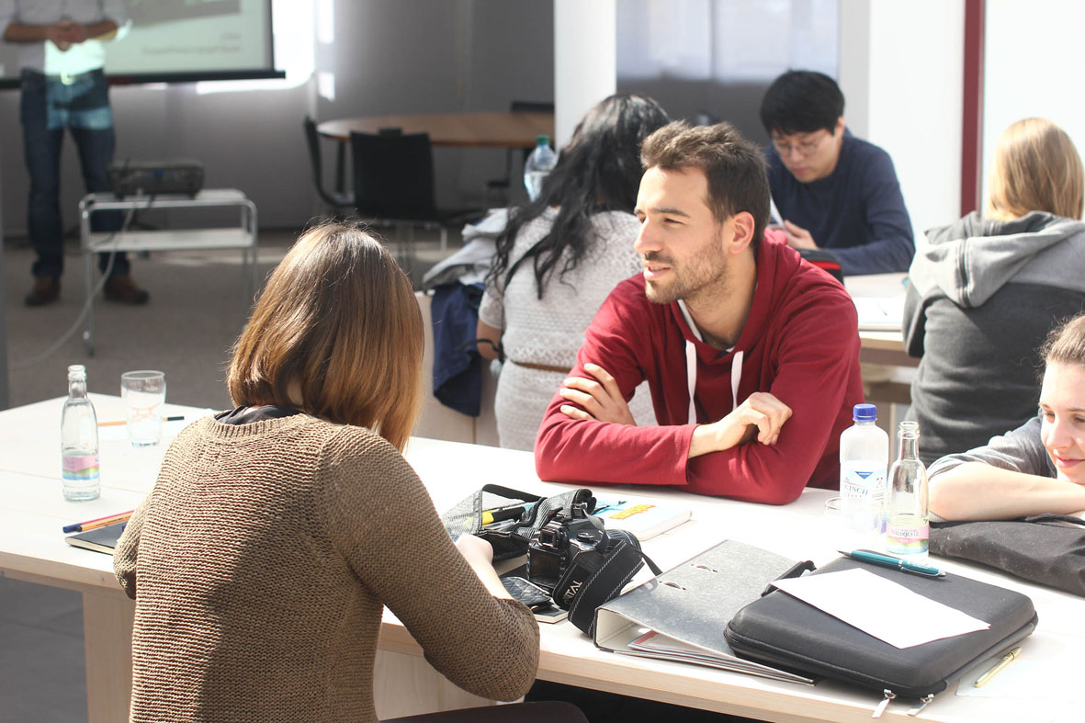
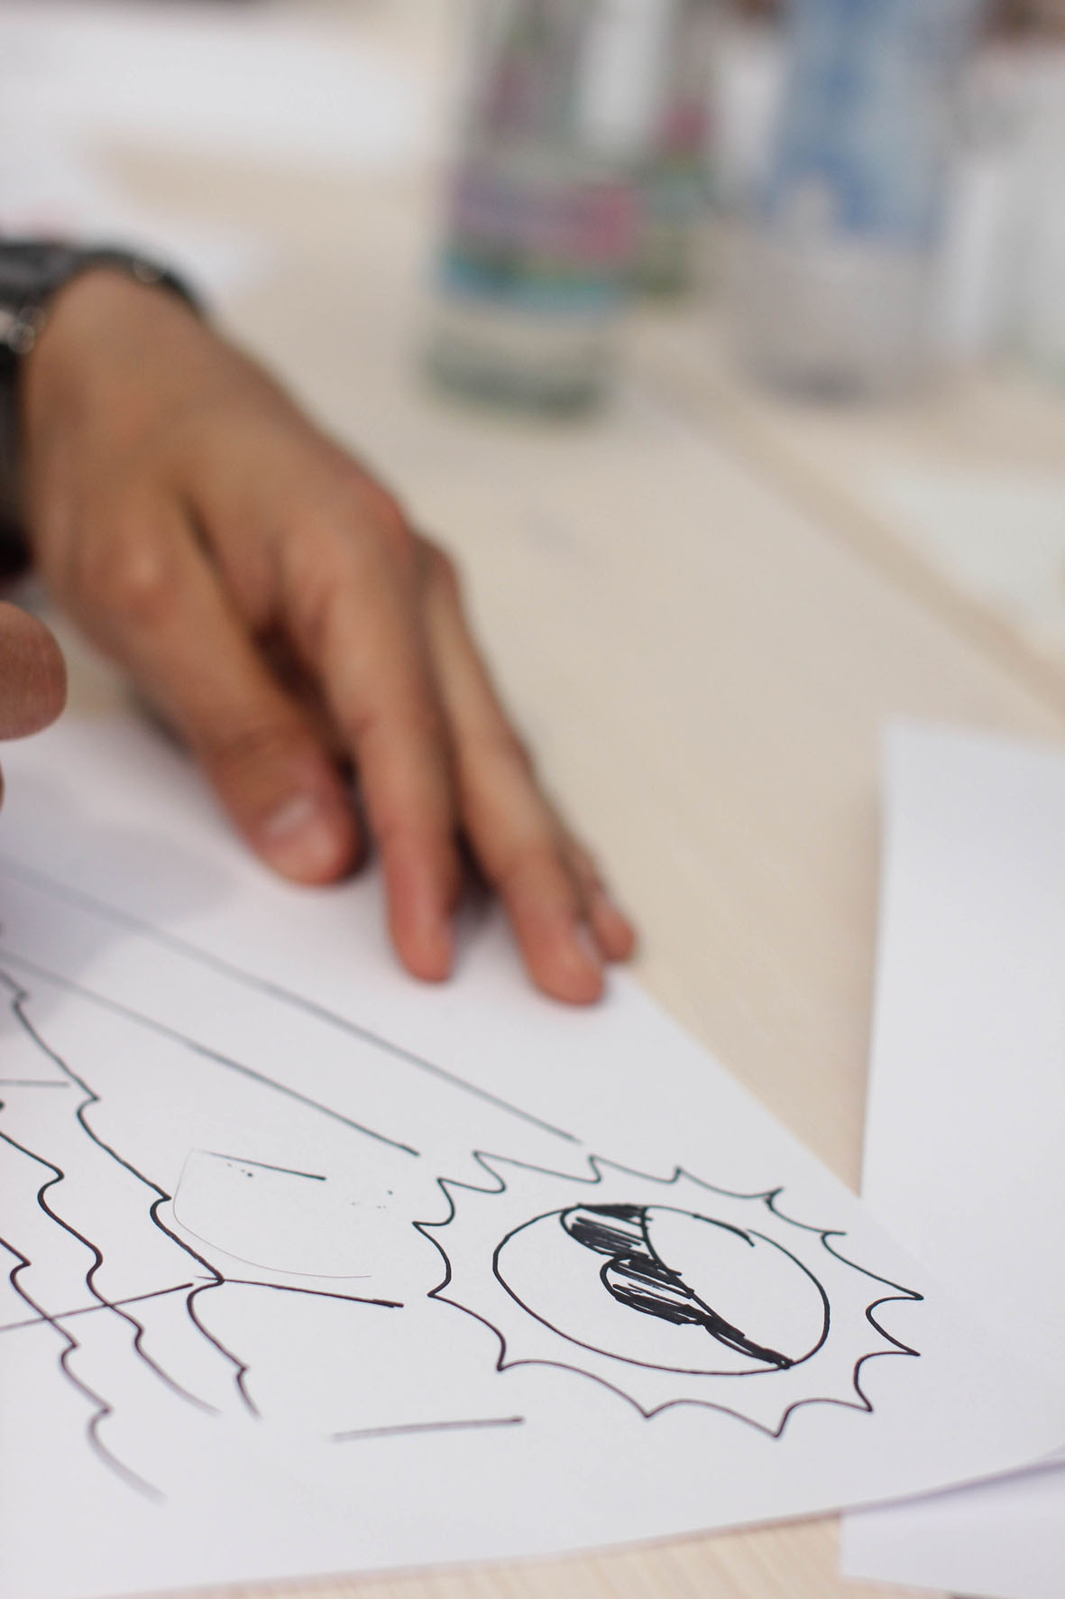
How will we illuminate furniture and rooms in the future? What trends will make their mark and how will the requirements and demands of users change with regards to lighting systems and lamps? Within the context of a six-month practical project entitled ‘Lichtkörper’ (Lightbodies) – which is aimed at providing insight into the product development and the production at GERA Leuchten – 18 design students at the University of Halle are currently focussing on these and other questions under the auspices of Professor Dieter Hofmann. The objective is to develop ideas for their own visions and to implement these in the form of concrete products. The results will be presented this coming October: at the Orgatec trade fair in Cologne, GERA Leuchten will be featuring an exclusive area for project ideas, all originating from, and implemented by, the young, aspiring designers, who will be awaiting the feedback from the experienced trade audience at the show.
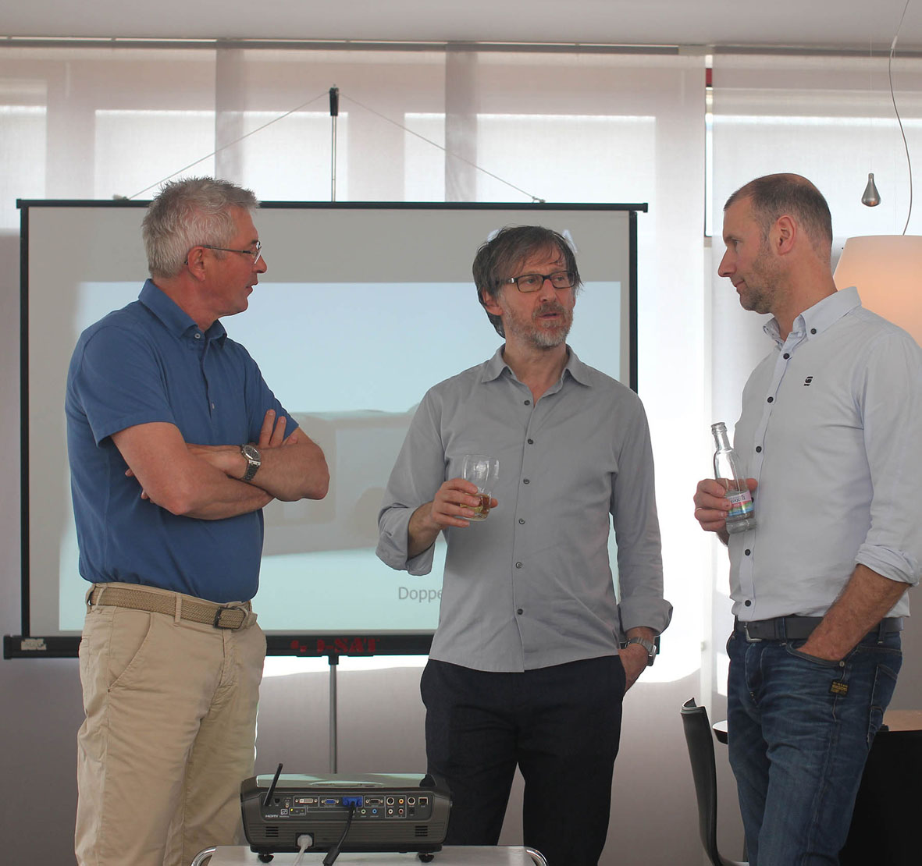
The person accompanying the project, Professor Dieter Hofmann, describes GERA Leuchten as the perfect collaboration partner, as the company has – in addition to its classic product ranges – focussed intensively with the topic of light design and has already developed and launched several items of its own illuminated furniture. “This is a veritable treasure trove for our students, because they can draw on extensive experience”, summarises Dieter Hofmann, talking about the fundamental conditions for the project.

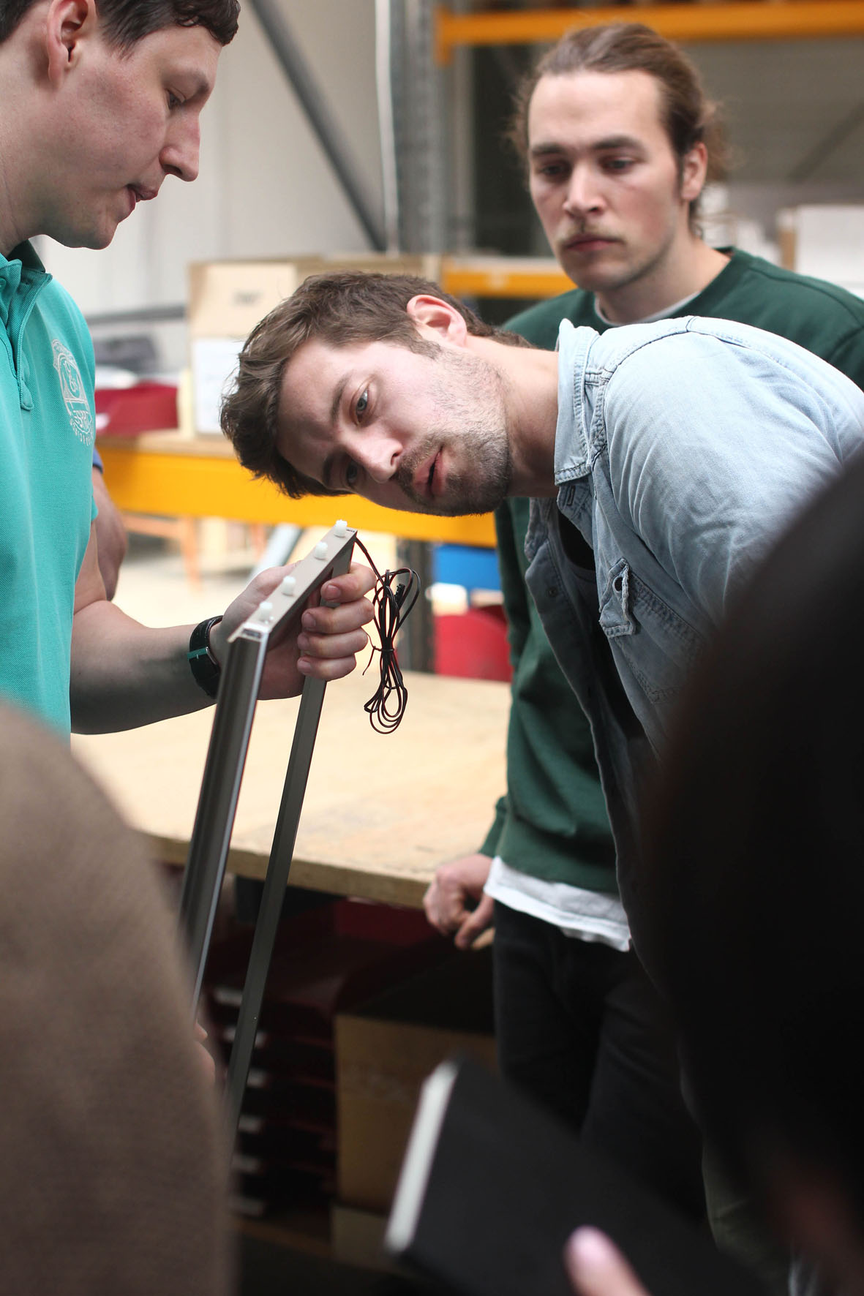
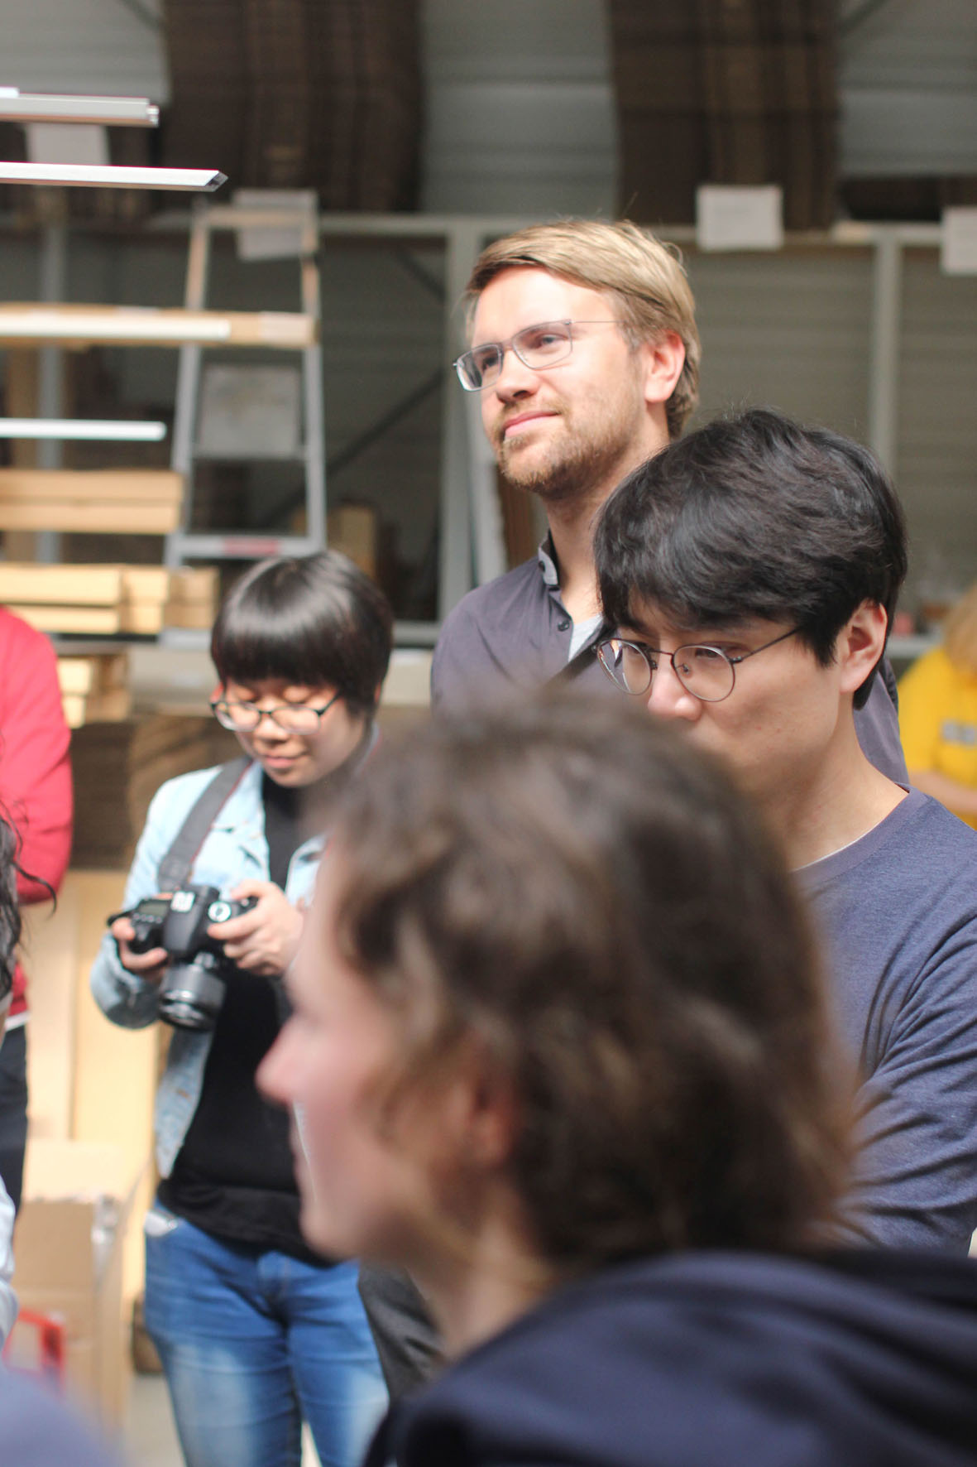
GERA Leuchten regards itself as a companion and consultant for the students and hopes to engage in lively dialogue with the students from all over the world, who will be both the designers and consumers of future product developments. “The students are practically bringing a future external perspective to the table and it is for this reason that we are thrilled by this collaboration and assume that the young people will develop many interesting ideas that they can transform into prototypes at our facilities, among others”, states Hening Pölitz, Managing Director and shareholder of GERA Leuchten. Within the company, Thomas Ritt is acting as the coordinator between the various interests. At GERA Leuchten, he represents the design department and hence has the most direct access to the study contents of his external protégés. For him, one main focus lies on balancing the unbridled self-confidence of these young creatives and the resulting initial, visionary designs with technical feasibility and the real demands of the market. “I am absolutely overwhelmed by the commitment and the drive with which the students are reinventing lightbodies with their creative approaches. The industry can now look forward to seeing the results, which we will be presenting at the Orgatec trade fair”, discloses Thomas Ritt.

Overview of the picture data
Captions:
File GERA_projectUni_I, GERA_projectUni_IV and GERA_projectUni_III: The students inform themselves about the GERA Leuchten lighting systems.
File GERA_projectUni_II: The responsible project managers from left to right: Hening Pölitz, Managing Director and shareholder of GERA Leuchten, Professor Dieter Hofmann and Thomas Ritt, designer and product manager at GERA Leuchten.
File GERA_projectUni_IV: initial sketches by the students.

GERA_projectUni_I GERA_projectUni_II

GERA_projectUni_IV GERA_projectUni_III

GERA_projectUni_IV

