GERA Light Board 100: illuminated furniture in a minimalist design from GERA Leuchten
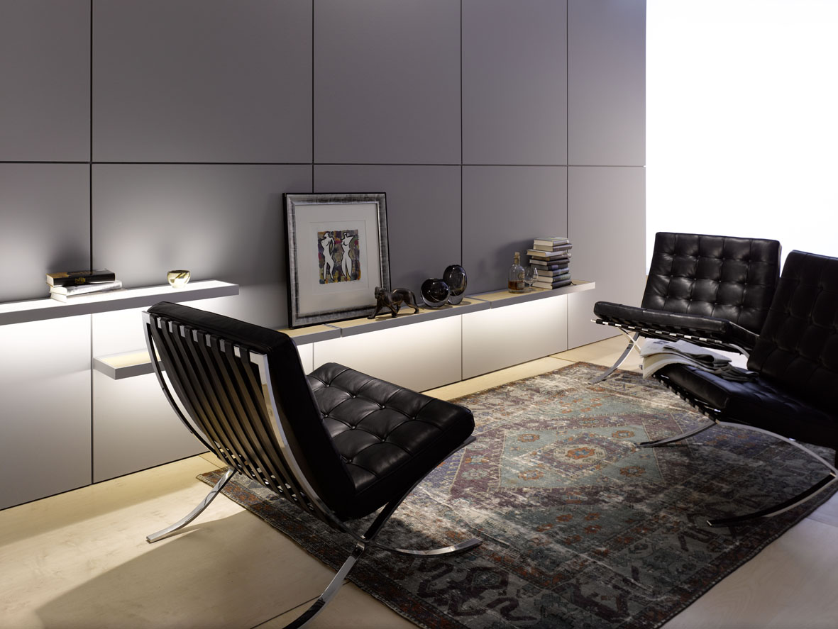
In the concepts for its illuminated furniture, GERA Leuchten uses an architectural design vocabulary characterised by minimalism and functionality. The GERA Light Board 100 also follows this philosophy. With this aesthetic, timeless product, the functions of lighting and load bearing merge to form harmonious lightweight, illuminated furniture. With its minimalistic dimensions and clear geometry coupled with high LED light performance, which is individually controllable, the GERA Light Board 100 has been created to adapt perfectly to the surroundings and simultaneously shape them.
With this concept, designer Thomas Ritt dispensed with unnecessary details. He systematically left out anything that was not necessary. “The product concentrates on the function for which it was created: presentation of objects and room zones with the aid of light”, explains the designer.
An illuminated glass shelf is inserted in the aluminium frame. Screws, angle brackets and the light source are mounted in such a way that they are not visible from the outside. A design aspect that adds to the clear design vocabulary and lightness of the furniture. The fully integrated, electronic light control can be fitted with white or colour adaptation upon request, making it possible for the user to individually choose the light colour. Moreover, all items of illuminated furniture from GERA can be combined and correspond with external LED sources and daylight. The result: a uniform lighting and room atmosphere perceived as natural by the observer. The GERA Light Board 100 is also available with a wooden floor made of light oak (non-illuminated), so that lighting and wooden shelf variants can be perfectly combined by means of an identical frame construction. The modular system therefore meets all the requirements of modern comfort.
The GERA Light Board with a load-bearing capacity of five kilograms is 100 cm wide, 21 cm deep and 4 cm high.

GERA Leuchten – the company
With its comprehensive knowledge of light design, furniture construction and electrical engineering, GERA Leuchten has also been developing its own furniture concepts, which – in combination with the corresponding lamps – are unique within the market.
With its characteristic illuminated furniture, the company has created a whole new product category, which always strives to create a double benefit by uniting the functions of illuminating and load-bearing. The design of the individual products is the result of the dimensional system of an overarching product family. Formal stringency, design simplicity, authenticity and logic come together in products whose style is characterised by timelessly-functional form.
Needless to say, all GERA products also comply with the very highest quality demands and carry the ‘Made in Germany’ seal of approval. This is guaranteed by the ISO-certified manufacturing process and the highly-qualified GERA employees.

Image data in the overview

GERA_Lichtbord_100

