GERA Light Board 100: customised illuminated furniture in a minimalist design for modern kitchens
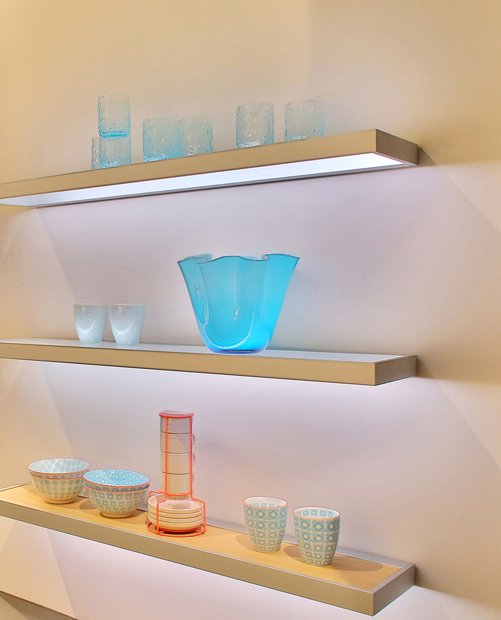
In the concepts for its lighting systems and illuminated furniture, GERA Leuchten uses an architectural design vocabulary characterised by minimalism and functionality. The GERA Light Board 100 also follows this philosophy. With this aesthetic, timeless product, the functions of lighting and load bearing merge to form harmonious, lightweight illuminated furniture. With its minimalist dimensions, clear geometry and thanks to the modular structure coupled with high LED light performance that can be individually controlled, the GERA Light Board 100 can be integrated into different kitchen collections, to which it lends individual flair at the touch of a button.
The GERA Light Board 100 is designed as a customised modular system. An illuminated glass shelf or a wooden shelf (non-illuminated), which can be selected by the kitchen manufacturer, is placed into an aluminium frame. By doing this, the producers can also accommodate their own wood colours and thus selectively capture the colour of the furniture again in the Light board. In this way, the modular system specifically adapts to the design of the kitchen and meets all the requirements of modern comfort.
Screws, angle brackets and the light source are mounted in such a way that they are not visible from the outside. A design aspect that adds to the clear design vocabulary and lightness of the furniture. In addition, thanks to the electronic light control integrated in the product, it is possible to have the LEDs illuminated in either different nuances of white or in various colours and thus determine the light colour and intensity at any time – according to taste, mood and requirements. In addition, the product can be combined with all other light systems and illuminated furniture from GERA Leuchten, and corresponds with external LEDs and daylight. The result: a uniform lighting and room atmosphere, perceived as natural by the observer.
With his concept, the designer Thomas Ritt dispensed with unnecessary details. He systematically left out what was not necessary and designed a Light board which did not itself feature in the foreground but in its surroundings – in the kitchen and the objects placed directly on the shelf – providing the desired expressive power. “The product concentrates on the function for which it was created: presentation of objects and room zones with the aid of light.” explains the designer. The GERA Light Board 100 is 100 cm wide, 21 cm deep, 4 cm high, and with a load-bearing capacity of up to five kilograms is constructed in such a way that it can replace light wall-unit functions and also illuminates the work surface.
With this innovative, adaptable product, GERA Leuchten is specifically helping kitchen manufacturers to distinguish themselves on the market and within their own collections and to provide each kitchen with its own unique character. For as the centrepiece of any home and as an increasingly open space in which guests are also received, the individual layout of kitchens is now becoming more important than ever. Consumers are looking for a kitchen that is perfect for them, meets their requirements exactly and through which they can express their own personality. Here production of a holistic atmosphere, to which light makes a considerable contribution, and creation of surfaces for deliberate presentation of objects play a central role.

GERA Leuchten – the company
With its comprehensive knowledge of light design, furniture construction and electrical engineering, GERA Leuchten has also been developing its own furniture concepts, which – in combination with the corresponding lamps – are unique within the market.
With its characteristic illuminated furniture, the company has created a whole new product category, which always strives to create a double benefit by uniting the functions of illuminating and load-bearing. The design of the individual products is the result of the dimensional system of an overarching product family. Formal stringency, design simplicity, authenticity and logic come together in products whose style is characterised by timelessly-functional form.
Needless to say, all GERA products also comply with the very highest quality demands and carry the ‘Made in Germany’ seal of approval. This is guaranteed by the ISO-certified manufacturing process and the highly-qualified GERA employees.
Image data in overview

GERA_Lichtbord_100

