Experience Light: successful trade fair appearance for GERA Leuchten at imm cologne
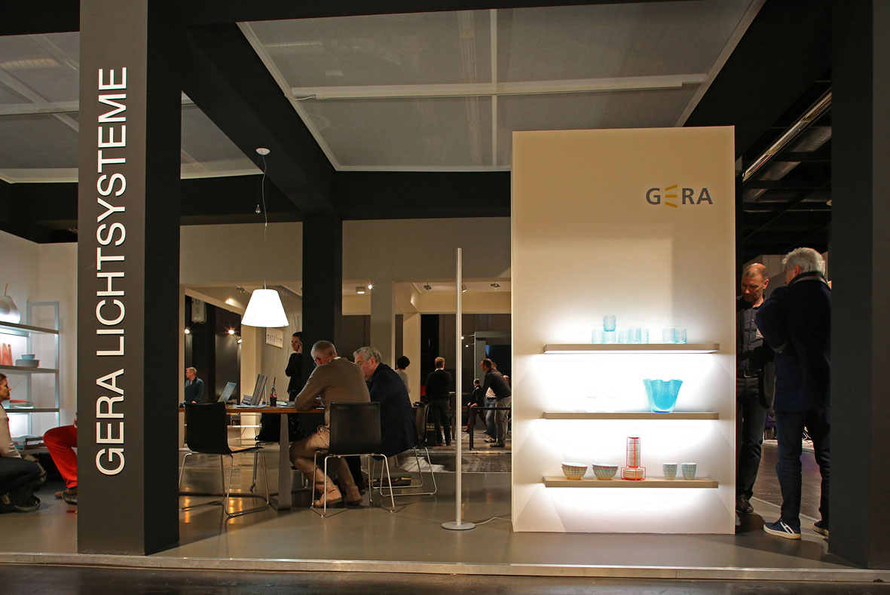
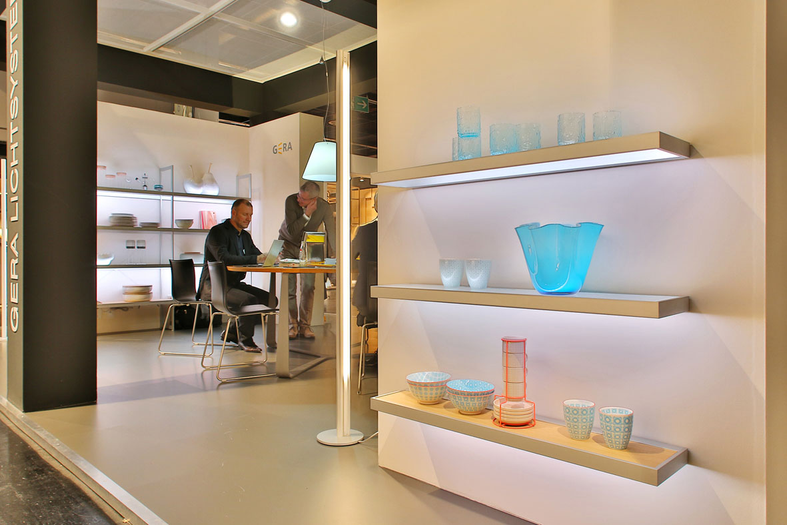
This year, under the Experience Light heading, GERA Leuchten invited visitors to imm cologne to see for themselves the presentation power of the products, for which the colour and intensity of the light can be individually controlled. These include the new GERA Light Board 100, customized illuminated furniture with a minimal design for modern kitchens and living spaces.
Compared to previous years, the team from GERA Leuchten welcomed even more interested visitors to the stand, who took advantage of the opportunity to see the effect of the various light scenarios for themselves. “The theme of integrated light planning and the possibility to individually control light systems has arrived on the market. At the same time, recognition of our products has increased considerably”, reports Hening Pölitz, CEO of GERA Leuchten.
Dealers, planners, designers and interior architects as well as end customers acquainted themselves on site with the illuminated furniture of GERA Leuchten and the associated advantages for space-light planning. “We are particularly pleased with the high demand and the specific interest in our products. We already received several orders at the trade fair”, said Hening Pölitz.

GERA Leuchten – the company
With its comprehensive knowledge of light design, furniture construction and electrical engineering, GERA Leuchten has also been developing its own furniture concepts, which – in combination with the corresponding lamps – are unique within the market.
With its characteristic illuminated furniture, the company has created a whole new product category, which always strives to create a double benefit by uniting the functions of illuminating and load-bearing. The design of the individual products is the result of the dimensional system of an overarching product family. Formal stringency, design simplicity, authenticity and logic come together in products whose style is characterised by timelessly-functional form.
Needless to say, all GERA products also comply with the very highest quality demands and carry the ‘Made in Germany’ seal of approval. This is guaranteed by the ISO-certified manufacturing process and the highly-qualified GERA employees.
Image data in the overview

GERA_Lichtbord100_imm GERA_Lichtbord100_imm2

