Table of contents:
Elegant minimalism:
GERA Leuchten presents itself in black Pages 2-7
GERA Light Board 100 Pages 8-12
Niche Rail GERA LS 6 Pages 13
GERA Light Shelf Pages 14-17
GERA Wall Shelf Pages 18-19
Pendulum Lamp GERA 40 x 10 LS 6 Page 20
GERA Avion standard and wall lamp Page 21-22
Coat Rack Lamp GERA LS 8 Page 23
GERA Leuchten – the company Pages 24-25
Overview of the picture data Pages 26-27
The complete text & photo materials can be
found on the enclosed CD-ROM.
Elegant minimalism:
GERA Leuchten presents itself in black
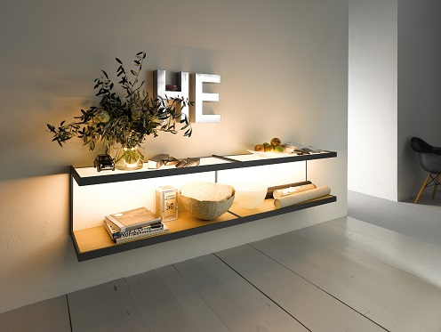
The colour black lends purism, elegance and a hint of luxury to spaces. It is timeless and brings structure to light-coloured spaces and furniture. In combination with light, black design almost becomes magic and, as a result, a design element that presents spaces effectively. Black furnishing elements – just like individually adjustable light sources – bring out the main features, stand out from the crowd and are the expression of personal interior design tastes and lifestyle. So it is no wonder that GERA Leuchten, whose products perfectly combine load-bearing and illuminating functions, has studied the requiremements of the minimalist, classic lifestyle in great depth and will be presenting its lighting systems and illuminated furniture with a new look at interzum 2015: all products have been manufactured in black-brown anodised aluminium for presentation at the trade fair.
Breaking the mould with design competence
and a flair for trends
The company, which has already won numerous prizes and awards for the design of its functional and clearly arranged products, has again demonstrated its design competence and flair for new trends. “Thanks to a congruent language of form, in recent years we have created a brand with a high recognition value and will continue to pursue this strategy systematically. Yet good design consistently requires the freedom and courage to break the mould. And I am delighted that as a niche supplier we meet this requirement and will surprise visitors to the trade fair with a new look”, says managing director of GERA Leuchten Hening Pölitz. The design in black fits perfectly into the puristic design language of current furnishing trends – while at the same time allowing GERA lighting systems and illuminated furniture to create a completely new effect.
Standing out from the crowd:
combining with black, emphasising features
“Even though light-coloured furniture is currently often fitted in kitchens and living areas, a living trend is emerging that is defined by reduced forms and dark colours. At interzum, we will show that kitchen and living room furniture manufacturers can meet these requirements with our GERA lighting systems, and can give their products a special something in terms of both the form and colouring of lighting and the light effect. For it is precisely in combination with light colours that our lighting systems develop a particularly elegant and, at the same time, cosy effect”, says Thomas Ritt, designer and product manager at GERA Leuchten. It will be decided later in the year which products in the new design variant will go into series production. “Not only our products but the entire stand design will stand out from the mass of lighting systems. Those who automatcially think of a light-coloured ambiance for the presentation of lighting systems will be surprised. We are excited about feedback from the trade fair visitors”, says Hening Pölitz.

A glance at something special:
design solutions for niches
As usual at interzum, in addition to presentation of the new product colour, GERA Leuchten will be concentrating on presenting light as a design factor in all its facets. Light as one of the most important interior design components allows objects to emerge or fade into the background and has an exhilerating or calming effect. It modulates the room, gives it contours and can conceal as desired. GERA Leuchten integrates these shaping aspects into its products in the form of high-quality controllable LEDs. At the same time, the products assume a load-bearing furniture function. With this sophisticated functionality, users receive double benefit in terms of interior design that takes space-light design to a new level. This year, GERA Leuchten is focusing on illuminating the niche. Flat lighting elements or anti-glare railing systems, which are equipped with basic central functions such as power supply or storage possibilites, lend the niche a new character. “This year we are literally living up to our respected market position as a niche supplier. Not only because we are introducing an extraordinary new product colour. But because we are paying specific attention to the design of what is currently the most important planning area in the kitchen – the niche”, says Thomas Ritt, putting it in a nutshell.

GERA Light Board 100: customised illuminated furniture in a minimalist design for modern kitchens
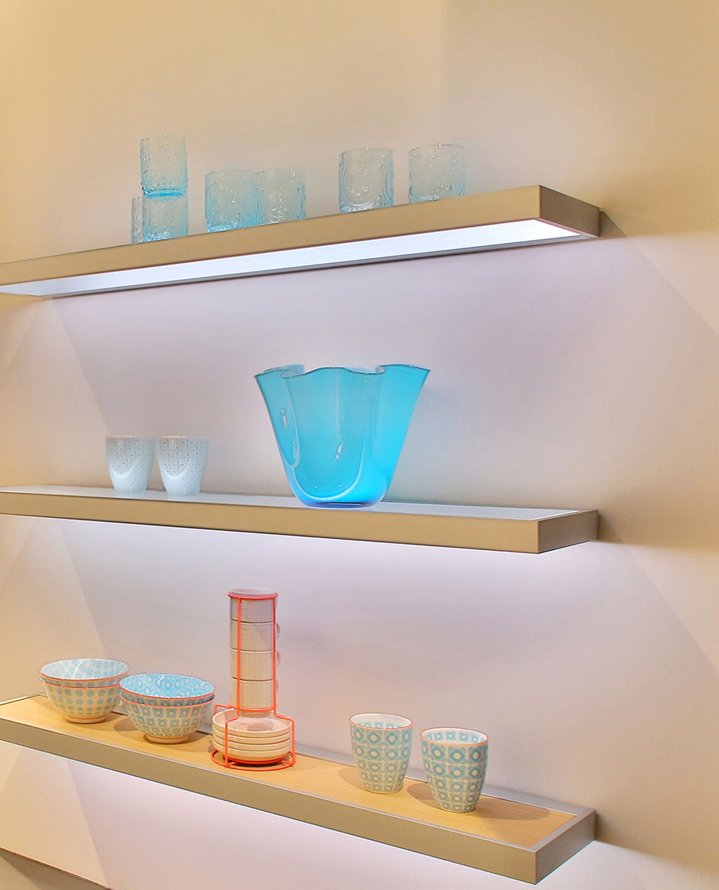
In the concepts for its lighting systems and illuminated furniture, GERA Leuchten uses an architectural design vocabulary characterised by minimalism and functionality. The GERA Light Board 100 also follows this philosophy. With this aesthetic, timeless product, the functions of lighting and load bearing merge to form harmonious, lightweight illuminated furniture. With its minimalist dimensions, clear geometry and thanks to the modular structure coupled with high LED light performance that can be individually controlled, the GERA Light Board 100 can be integrated into different kitchen collections, to which it lends individual flair at the touch of a button.
The GERA Light Board 100 is designed as a customised modular system. An illuminated glass shelf or a wooden shelf (non-illuminated), which can be selected by the kitchen manufacturer, is placed into an aluminium frame. By doing this, the producers can also accommodate their own wood colours and thus selectively capture the colour of the furniture again in the Light board. In this way, the modular system specifically adapts to the design of the kitchen and meets all the requirements of modern comfort.
Screws, angle brackets and the light source are mounted in such a way that they are not visible from the outside. A design aspect that adds to the clear design vocabulary and lightness of the furniture. In addition, thanks to the electronic light control integrated in the product, it is possible to have the LEDs illuminated in either different nuances of white or in various colours and thus determine the light colour and intensity at any time – according to taste, mood and requirements. In addition, the product can be combined with all other light systems and illuminated furniture from GERA Leuchten, and corresponds with external LEDs and daylight. The result: a uniform lighting and room atmosphere, perceived as natural by the observer.
With his concept, the designer Thomas Ritt dispensed with unnecessary details. He systematically left out what was not necessary and designed a Light board, which did not itself feature in the foreground but in its surroundings – in the kitchen and the objects placed directly on the shelf – providing the desired expressive power. “The product concentrates on the function for which it was created: presentation of objects and room zones with the aid of light.” explains the designer. The GERA Light Board 100 is 1000 mm wide, 21 mm deep, 4 mm high, and with a load-bearing capacity of up to five kilograms is constructed in such a way that it can replace light wall-unit functions and illuminates the work surface.
With this innovative, adaptable product, GERA Leuchten is specifically helping kitchen manufacturers to distinguish themselves on the market and within their own collections and to provide each kitchen with its own unique character. For as the centrepiece of any home and as an increasingly open space in which guests are also received, the individual layout of kitchens is now becoming more important than ever. Consumers are looking for a kitchen that is perfect for them, meets their requirements exactly and through which they can express their own personality. Here production of a holistic atmosphere, to which light makes a considerable contribution, and creation of surfaces for deliberate presentation of objects play a central role.

Niche Rail GERA LS 6
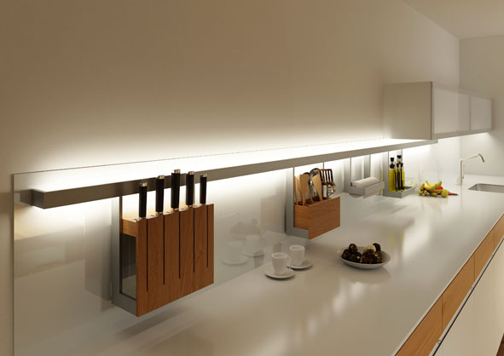
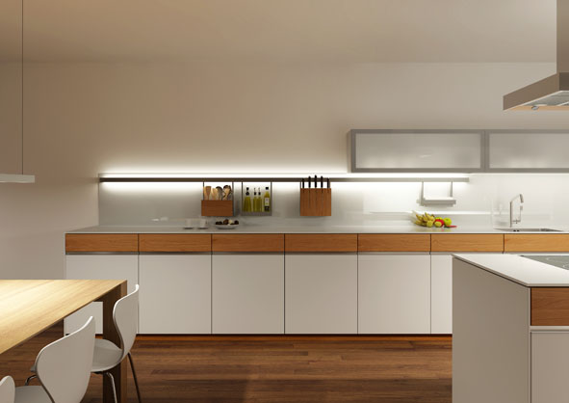
This all-rounder made from brushed aluminium transforms any kitchen niche into a visual highlight. The rail can be illuminated with neutral white, warm white or colour-changing light, hence blending perfectly into any room lighting concept. It comes with an integrated glass shelf, which is perfect for storing herbs and spices, for instance. Accessories include a knife block, a paper towel holder, a shelf and hooks, among other things. The rail can be installed in four standard lengths or customised in lengths of between 200 and 5000 mm and is equally suited for deployment in bathrooms, living rooms and office spaces.
GERA Light Shelf
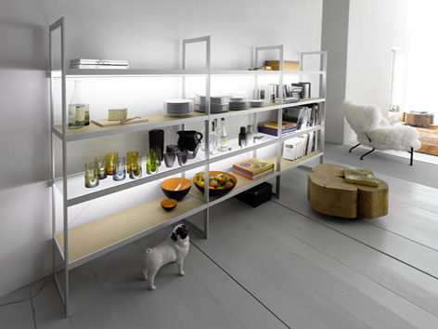
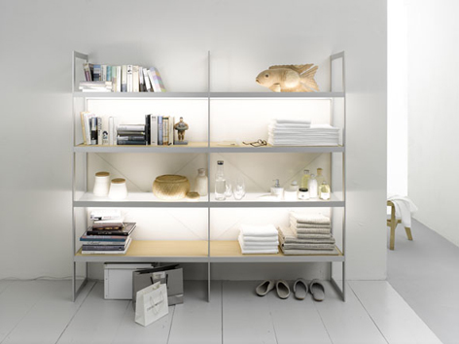
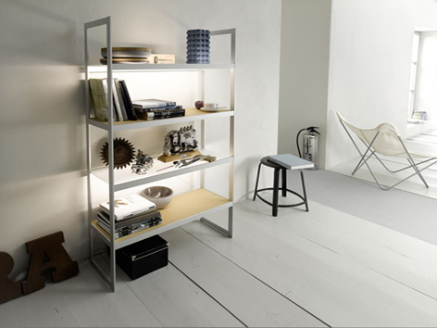
The exquisite GERA Light Shelf unites minimalist design with extraordinary functionality, stringently oriented on users’ requirements. The ScanAndLight function, which is integrated into the furniture and which measures and controls the light within the room and in each individual lamp, permits the user to control all the light in the room. Targeted microelectronic control of the LED colour components permits the creation of a constantly-adapting light mood throughout the entire room, which is perceived as being completely natural by the human eye.
The shelf is an impressive example of the unique radiance with which an integral lighting system is able to provide an item of furniture. Functionality and creative power ensure the GERA Light Shelf is far more than merely an item of furniture. Thomas Ritt describes it as “a timeless, refined and load-bearing shelving system that acquires its colour not through lacquer, but through light itself and which integrates itself into the room perfectly with its dramatic features.” In a nutshell: the shelf defines the light mood of the entire room, hence becoming the very heart of any lighting concept.
The GERA Light Shelf is 1840 mm high and 350 mm deep. It comes in three standard width variants: GERA Light Shelf 100, 200 and 300. As a single-width design, the GERA Light Shelf 100 is precisely 1000 mm in width. The double- and triple-width versions are 1990 mm and 2980 mm wide respectively.
While the GERA Light Shelf was available exclusively with glass shelves in the past, new designs now also include light oak, which place the focus more on cosy furniture design. Combined with the high-end, brushed aluminium frame, the two versions are characterised by formal stringency and design simplicity, which perfectly integrate into virtually any environment. The GERA Light Shelf reveals its entire creative power particularly in smaller spaces. In open plan areas, the GERA Light Shelf is able to create stylish transitional areas that pick up on – and merge – the moods of the two distinct spaces. In this way, the shelf can be positioned on the way to the living or dining area, to the office, the bath or the sauna, hence creating a fluid transition to the respective area by dispensing with the objects generally required there. The load-bearing, illuminating function coupled with the sleek design lend the GERA Light Shelf an absolutely unique character which can provide frequently neglected transitional areas with new design impetus.
GERA Wall Shelf
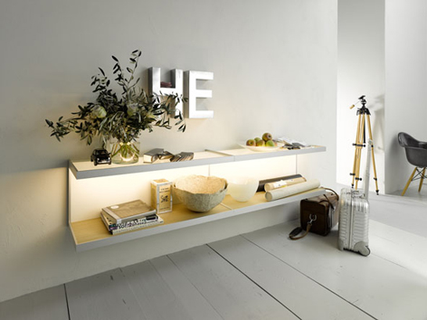
With the GERA Wall Shelf, clear functionality meets maximum staging impact. This furniture not only creates order, its radiant light also lends the surrounding space an elegantly-staged atmosphere. Equipped with the GERA ScanAndLight technology, this furniture harmoniously integrates into any light ambience or creates targeted light contrasts that define the character of the room and make the wall shelf almost appear to be a work of art.
The GERA Wall Shelf is available both with illuminated glass shelves or as a combination with wooden shelves in light oak. The height is 410 mm, the depth is 350 mm and the standard width is 1000 mm. Thanks to its special construction, two GERA Wall Shelves can be easily mounted in close contact to each other, without leaving any space in between. In this case, the width is 2000 mm. Thanks to its versatility, this minimalist and simultaneously mood-enhancing item of furniture can be used in the most diverse room situations.
Pendulum Lamp GERA 40 x 10 LS 6
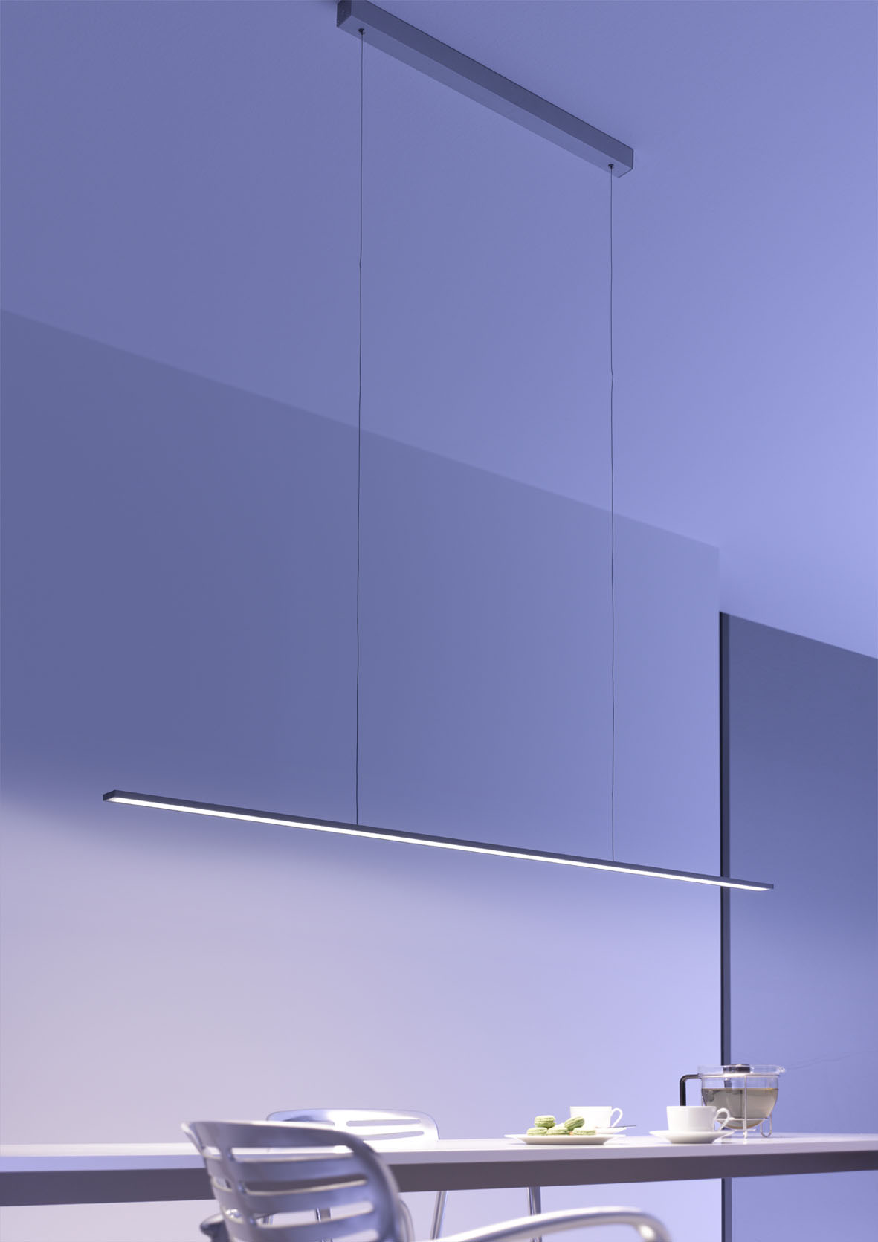
The elegant Pendulum Lamp GERA 40 x 10 LS 6 is a dream for all interior designers. With its extremely slim-line profile and the inconspicuous power supply thanks to the smallest conductor cross-sections, it appears to be virtually weightless and almost floating despite its impressive light emission. The option to customise both the length and the light temperature also provides total planning freedom and enables the lamp to be deployed as a pendant lamp above tables and counters, as a niche lamp in kitchens or as a mirror lamp in bathrooms.
GERA Avion standard and wall lamp
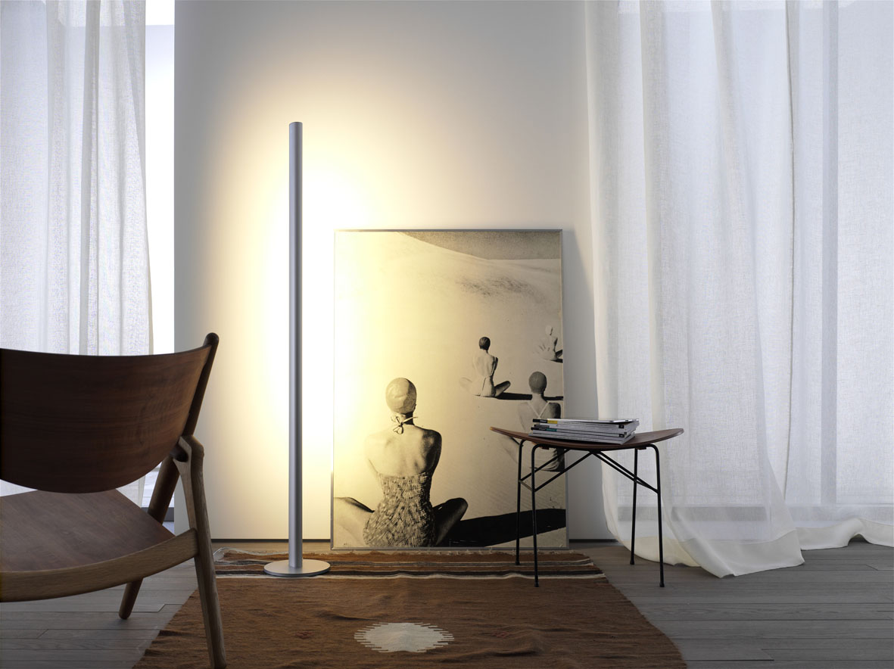
Thomas Ritt describes the design vocabulary of the product innovation from GERA Leuchten as follows: “The curved cross-section of the aluminium profile is reminiscent of the gentle shape of a bird or aeroplane wing”. Clean lines lend the design a timelessly-modern and extremely soothing radiance. The standard lamp is activated and dimmed contact-free and is available in white or in aluminium. And like all GERA lamps, it is perfectly suited for staging niches, corners or walls without placing itself centre-stage.
After the success of the GERA Avion standard lamp for the living area, there now follows the horizontal version that can also be used as a wall lamp in the adjacent living areas of the hall, bathroom and kitchen. In combination with the Linero railing system the Avion horizontal lamp becomes a functional multi-talent that lives up to the GERA motto “Light carries”.

Coat Rack Lamp GERA LS 8
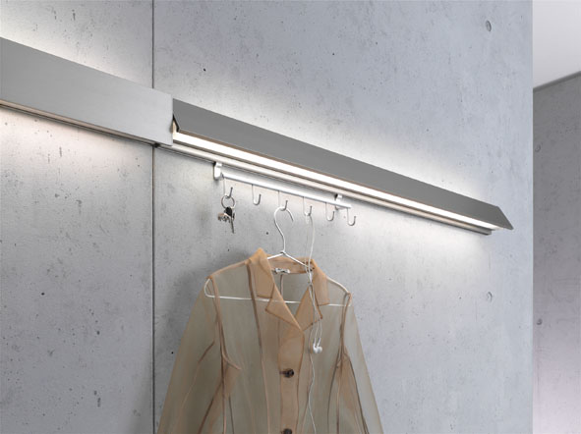
As in the case of all GERA Leuchten illuminated furniture, Coat Rack Lamp GERA LS 8 is an object that does more than just illuminate. The special feature of this architecturally-designed lamp is the option to insert one or more hook strips into a track concealed behind the lamp, permitting users to create a load-bearing coat rack, for example.
The product can be customised in terms of width and hence fills even smaller niches with sensible functions. In contrast, the addition of several lamps can result in interesting, linearly-aligned installation effects in longer corridors.
GERA Leuchten – the company
With its comprehensive knowledge of light design, furniture construction and electrical engineering, GERA Leuchten has also been developing its own furniture concepts, which – in combination with the corresponding lamps – are unique within the market.
With its characteristic illuminated furniture, the company has created a whole new product category, which always strives to create a double benefit by uniting the functions of illuminating and load-bearing. The design of the individual products is the result of the dimensional system of an overarching product family. Formal stringency, design simplicity, authenticity and logic come together in products whose style is characterised by timelessly-functional form.
Needless to say, all GERA products also comply with the very highest quality demands and carry the ‘Made in Germany’ seal of approval. This is guaranteed by the ISO-certified manufacturing process and the highly-qualified GERA employees.
Overview of the picture data

GERA_Wandregal_schwarz

GERA_Reling_LS6 GERA_Reling_Detail_LS6

GERA_Lichtregal_100 GERA_Lichtregal_200

GERA_Lichtregal_300 GERA_Wandregal

GERA_Pendelleuchte_LS6 GERA_Lichtbord_100

GERA_Stehleuchte_Avion GERA_Garderobenleuchte_LS8

