GERA Leuchten targets the niche at interzum and hits the mark
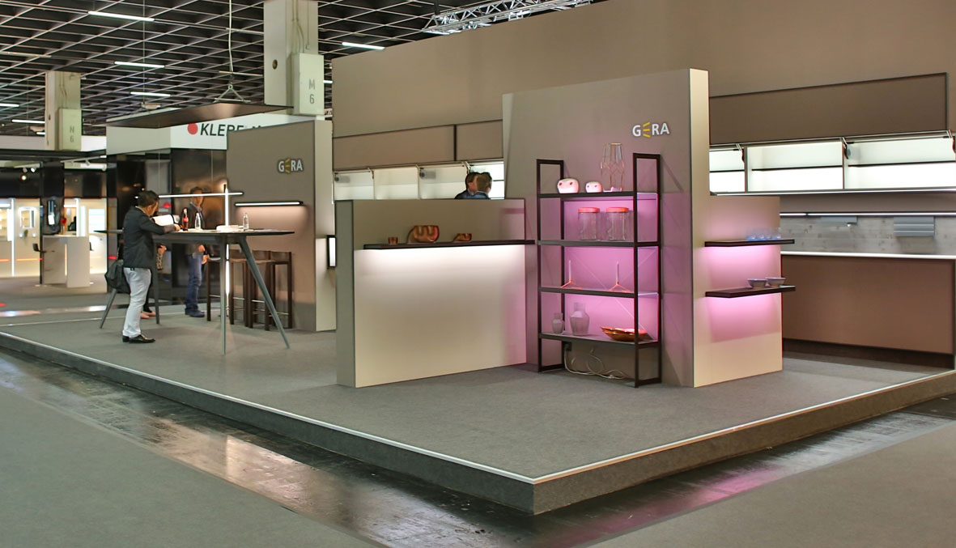
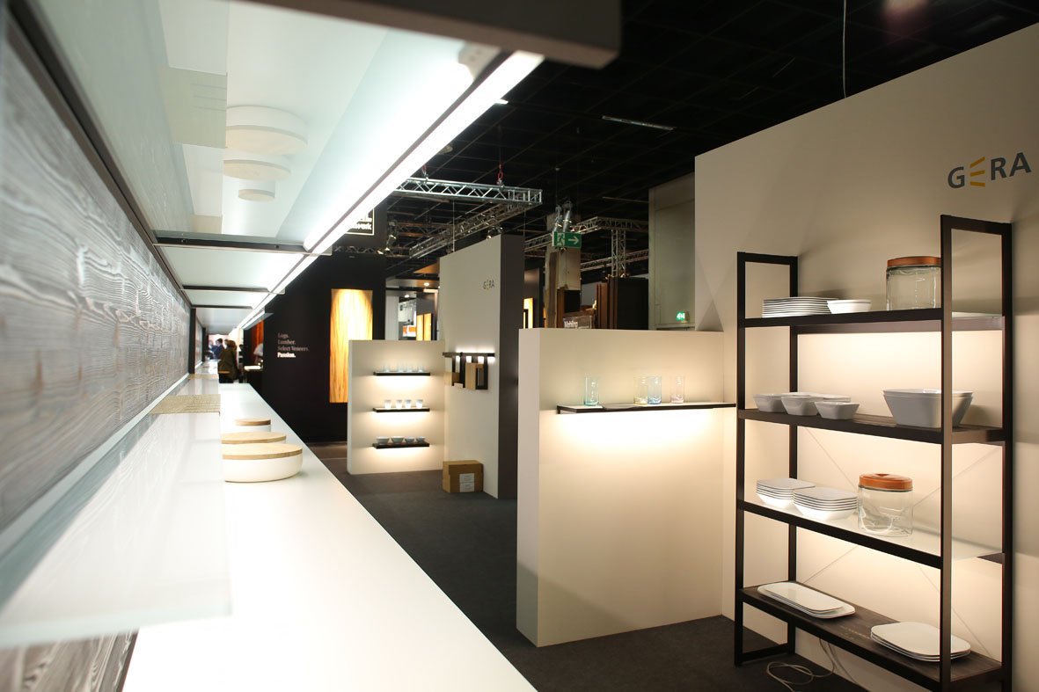
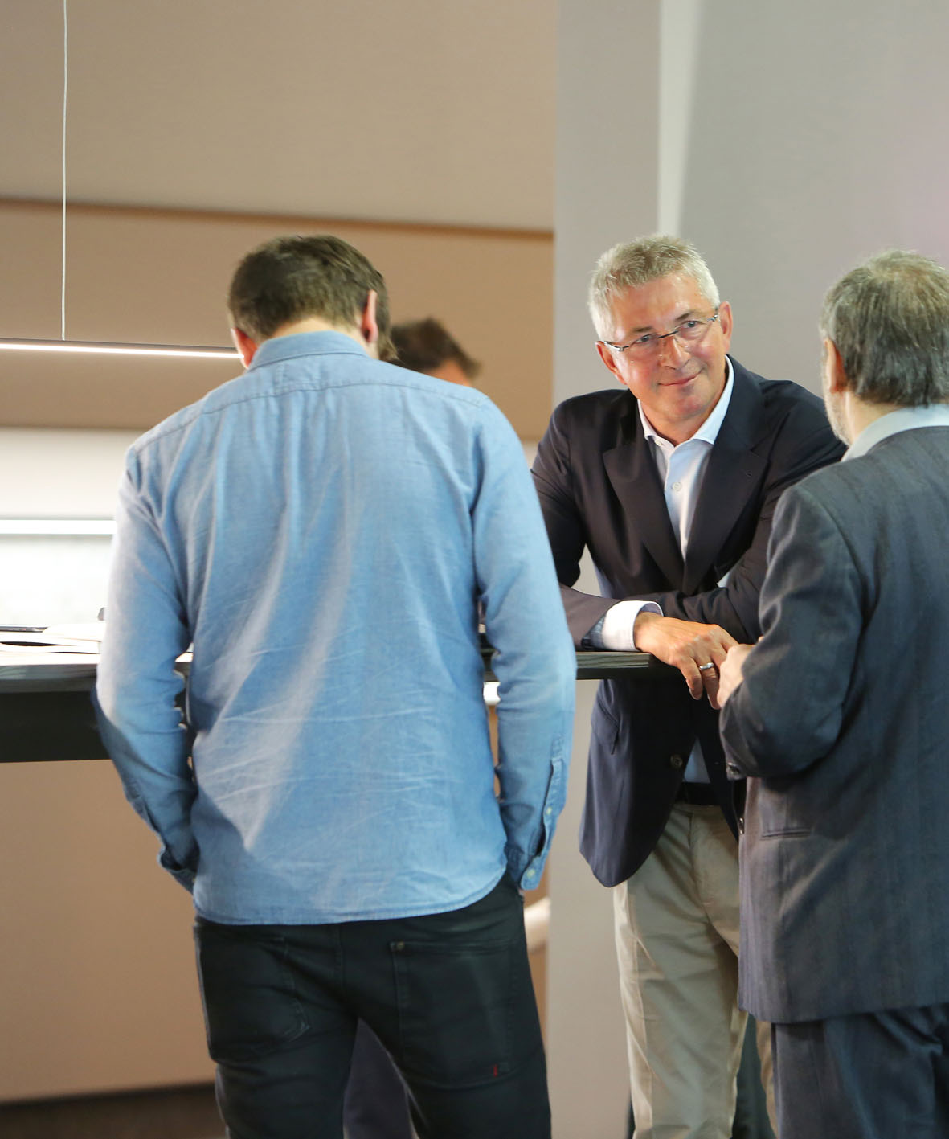
At this year’s interzum, GERA Leuchten impressively presented the influence of light on the effect of furniture and rooms. The manufacturer of high-quality lights and lighting systems based on LED showed its entire product range in black-brown-anodised aluminium and focused on designing niches with different lighting situations. “Our requirement as a partner of the furniture industry is to develop innovative light concepts with which manufacturers can provide additional contours to their furniture and emphasise the features. This year, it was possible for visitors to experience how simply changing the profile colour from silver to black-brown gave the lighting systems and therefore their surroundings a completely new quality. An effect with which we were even able to pleasantly surprise our longstanding customers”, says Hening Pölitz, CEO of GERA Leuchten. With the new colour, manufacturers can emphasise the puristic design of their kitchens and furniture and give each model its own character. For black furnishing elements are not only timeless and bring structure to light-coloured rooms and furniture, but – just like individually adjustable light sources – emphasise features, stand out from the crowd and are the expression of personal living and lifestyle. “Customers from southern Europe and Asia were particularly enthusiastic about the appeal of the new profile colour and the resulting puristic-elegant design”, says Hening Pölitz.
Besides the presentation of the new product colour, GERA Leuchten concentrated on representing the design factor light in all its facets and, in this context, focused on illuminating the niche. Two-dimensional lighting elements and various anti-glare railing systems, equipped with central basic functions such as power supply or storage possibilities, provided the kitchen niche on the trade fair stand with various effects based on their design and depending on the light colour and intensity. “The niche is and remains a central design factor in the kitchen. With three different niche lights, we have shown at a glance how individually designed and controlled light sources can create completely different atmospheres for one and the same kitchen unit. With our modular concept of lighting systems, which has the right solution for any piece of furniture, we specifically support kitchen and furniture manufacturers in offering their customers this crucial design advantage”, says designer and product manager Thomas Ritt.

GERA Leuchten – the company
With its comprehensive knowledge of light design, furniture construction and electrical engineering, GERA Leuchten has also been developing its own furniture concepts, which – in combination with the corresponding lamps – are unique within the market.
With its characteristic illuminated furniture, the company has created a whole new product category, which always strives to create a double benefit by uniting the functions of illuminating and load-bearing. The design of the individual products is the result of the dimensional system of an overarching product family. Formal stringency, design simplicity, authenticity and logic come together in products whose style is characterised by timelessly-functional form.
Needless to say, all GERA products also comply with the very highest quality demands and carry the ‘Made in Germany’ seal of approval. This is guaranteed by the ISO-certified manufacturing process and the highly-qualified GERA employees.
Overview of the picture data

GERA_interzum_1 GERA_interzum_2

GERA_interzum_3

Download link: http://bit.ly/GERALeuchten_Review

