GERA Light Shelf Q40: opening up space with light
“It is not an exaggeration to say that light is the key to architecture.” It comes as no surprise that the originator of this quote – leoh Ming Pei, the Chinese-American architect famed for his flamboyant buildings – attached great importance to lighting design in his projects. Light influences wellbeing and performance. Besides affecting people’s moods in various ways, it performs another valuable function: lighting is an extremely effective tool for interior design.
The new Q40 Light Shelf from GERA Leuchten uses this attribute to great advantage. Like GERA’s other light shelves, the Q40 has an innovative dual function: it combines lighting with shelving. The individual illuminated furniture is particularly suitable for special applications: every floor plan includes areas that do not get adequate daylight and which, from an interior design perspective, would benefit from greater brightness. Targeted lighting control can put corners, peripheral alcoves and corridors on an equal footing with areas in the vicinity of windows.
The Q40 Light Shelf achieves this harmonising effect in two ways. The options for adjusting its light to various daylight situations via white adaptation and the compact shelf function add up to a timeless architectural shelf that can open up otherwise neglected areas of the room and bring them to life.

About GERA Leuchten
Based in the central German state of Thuringia, GERA Leuchten uses its comprehensive expertise in lighting design, furniture construction and electrical engineering to develop furniture concepts which, when combined with the appropriate light sources, are unique within the market.
With the distinctive illuminated furniture in its “Light Furniture” collection, the company is establishing a whole new product category that seeks to provide a double benefit by combining two usually separate functions: lighting and shelving. The design of the individual products is based on the sizing system of an overarching product family. Strict lines, simplicity, authenticity and logic come together in products that owe their style to a timeless, functional design language.
Thanks to the ISO-certified production process and GERA’s highly-qualified staff, it goes without saying that all products meet the highest quality standards and are entitled to carry the “Made in Germany” label.
Overview of images

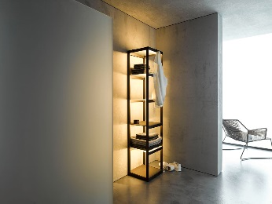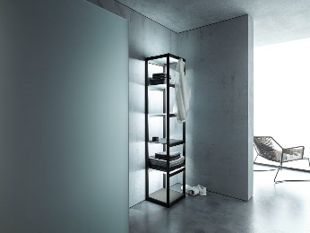
GERALeuchten_Q40_1 GERALeuchten_Q40_2

