Table of Contents
"Light carries": GERA Leuchten at the imm cologne Page 2-4
Portable light: a design process becomes a product Page 5-10
GERA ceiling light: architecture in the genes Page 11-12
GERA light shelf Q40: open up a space with light Page 13-14
GERA sideboard 100/200: the pure presence of light Page 15-16
Pendant light 20/10: Lighting that seems to float Page 17-18
The GERA Leuchten company Page 19-20
Overview of image data Page 21-23
You can also find the text and image material on the enclosed CD ROM.
"Light carries":
GERA Leuchten at the imm cologne 2017
"Light is no longer merely emitted from a lamp, it needs a source," says product manager and designer Thomas Ritt. This philosophy governs GERA Leuchten's approach to product design. This light source can be integrated into furniture at the point of its construction in a non-obvious way, thereby extending the range of possibilities when it comes to furniture design, which in turn increases the spectrum of options available to lighting specialists. GERA Leuchten unites both aspects. The company combines room lighting and the functional purpose of a piece of furniture to create minimalist, elegant lighting furniture. GERA Leuchten's range of ordinary lighting is also impressive. The clear and understated designs make the lights very unobtrusive. "We consciously reduce the design of our lights down to a minimum. We are merely putting a source of light into a multi-functional setting," explains Thomas Ritt. For both product groups, the company offers the option of variable, controllable lighting colours as GERA Leuchten considers this to be key to adapting furniture and rooms to the respective individual requirements and different moods.
GERA Leuchten presented its new products at the imm cologne 2017, including two pieces of so-called lighting furniture, the sideboard 100/200 and the lighting shelf Q40, as well as two lights: the pendant light 20x10 and a ceiling light. All four products are characterised by the product philosophy that defines all GERA Leuchten lighting solutions: clear design, elegance, sophisticated materials and an interior architecture approach to the topic of lighting, an aspect that is increasingly gaining in importance due to the advancing miniaturisation of light sources.
This year's trade fair presentation, entitled "Light carries", also focuses on an additional highlight: two light designs that are the result of a long-term cooperation with Burg Giebichenstein University of Art and Design Halle. At the imm cologne, the trade fair visitors can see for themselves just how well both designs match the GERA Leuchten product philosophy.
Portable light: a design process becomes a product
Progressive lighting design, the future of miniaturised lighting technology, exploring new forms of lighting and new ways in which to use them – GERA Leuchten's brand and product development focuses on taking the wide range of possibilities offered by lighting one step further. That is why the company regularly exchanges ideas with market-relevant groups such as retailers, engineers and architects but also looks at all facets of lighting together with a new generation of designers in order to already create designs that meet the future needs of the people who use them and look at them today. At the imm cologne 2017, GERA Leuchten will now be presenting two initial protoypes of designs that are the result of two cooperative efforts involving students and young designers currently studying at University of Art and Design Halle.
"In 2014, GERA Leuchten was the first and initially the only industry partner to become actively involved in university projects within the scope of the interzum/Material Transformation initiative. At the time, we found a couple of excellent partners in the Burg Giebichenstein University of Art and Design Halle and Professor Dieter Hofmann," says Hening Pölitz, the GERA Leuchten CEO. The results of the six-month practical project on the topic of "Bodies of Light" were already presented at the 2014 Orgatec. GERA Leuchten's decision-makers thought that one of the projects offered particular potential and decided to develop it further to prototype maturity: the light "TeO", designed by the young Korean designer Jeho Yoon. The light's clear form and intuitive controls perfectly match GERA Leuchten's minimalist style and typical "kit" principle.
The second design, "ZiMu", by the Chinese Masters student Haiwei Ye, evolved from another research project that was also carried out in cooperation with the Burg Giebichenstein University of Art and Design Halle. In this instance, the research partner was the company Naber, represented in person by the Naber family. This time round, GERA Leuchten designer Thomas Ritt took on the practical supervision of the winter semester 2015/16 project "Taking in the Kitchen", which focused conceptually on innovative manufacturer designs for kitchens.
The students came up with a total of 17 impressive product ideas, and the company felt that the future-oriented light designed by Haiwei Ye was particularly suitable for further development. He soon agreed to realise his concept for a light, "ZiMu", which means "Mother and Son", together with GERA Leuchten. "ZiMu" is a pendant light that consists of a floating base and four individually removable lighting units. If necessary, the lighting units, which are automatically recharged when they are attached to the base, can be carried to wherever they are needed. Away from the base unit, they provide light for around 1-2 hours. Together with the specialists from GERA Leuchten, Haiwei Ye developed this innovative basic concept further. It will now be exhibited at the imm cologne as the second result of the university projects.
"Both projects are the inevitable result of a long-term research process with a specific purpose," says Thomas Ritt. "As LED technology is becoming more advanced, it lifts the constraints of having to hang onto the established designs due to their functional necessity. Lights no longer have to be designed around a bulb-shaped light source. This makes innumerable new product design shapes possible, which we intend to explore together with a wide range of different experts." As a company that is leading in the area of innovations, GERA Leuchten is always looking for new impulses, changing perspectives and progressive ideas. That is why contact with the coming generation of designers is especially important to the company: "This is not just about new products. It is about the creative dialogue; about a targeted innovation process we intend to firmly implement in our as yet recently evolved corporate culture," says Thomas Ritt. The students, in turn, profit from the company's experience: "I was given plenty of inspiration, in terms of design and also in terms of concept development. Plus tips on the technical and the commercial side," says Haiwei Ye. "Learning more about the actual construction and manufacturing methods allowed me to adapt and optimise my design. And the dialogue with experts from different disciplines greatly expanded my horizon."

GERA ceiling light: architecture in the genes
Two words are all it takes to aptly describe GERA's unusual new ceiling light: lighting architecture.
When you talk about architecture, humankind's approach to enclosed, constructed spaces, people usually think of materials with different textures you can feel. Although lighting has always been a classic component of architectural design, it tends to be considered merely from the perspective of introducing natural light to rooms. However, the lighting aspect is increasingly gaining in importance: artificial light has evolved into a stylistic architectural device. Beyond its ergonomic function of lighting a space, light also emphasises architectural elements and illustrates their interrelation. Linear light sources such as the new GERA Leuchten ceiling light are particularly suitable for adding emphasis to certain areas and angles of the outside or inside of a building. Their elongated contours visually concretise direction and dimension. The ceiling light 40x40 has architecture in its genes. Its square diameter is a perfect match for geometrical interiors. It is bright but not glaring; its size is adjustable and it can be integrated horizontally as well as vertically. It is available in two surface finishes: aluminium-coloured or with a brownish-black anodic oxide finish.

GERA light shelf Q40: open up a space with light
"The essence of architecture is form and space, and light is the essential element to the key to architectural design, probably more important than anything." It is hardly surprising that the originator of this quote, the Chinese-American architect Ieoh Ming Pei, who has a reputation for designing particularly extravagant buildings, attaches major importance to planning how they will be lit. Light has an impact on our well-being and productivity. It influences people's moods and also has another valuable function: when it comes to interior design, lighting is an extremely effective design device.
GERA Leuchten's new light shelf Q40 fully exploits this aspect. Like all of GERA's other light shelves, the Q40 also has the innovative dual function of providing a storage or display surface as well as light. This compact piece of lighting furniture is particularly suitable for specific interior situations: all floor plans feature some areas that are not exposed to natural light; however, from an interior design perspective, it is vital that these areas are also lit. Targeted, controlled lighting allows room corners, peripheral niches and corridors to be as light as spaces near windows.
The light shelf Q40 achieves this compensating effect in two ways. The light it emits can be adapted to natural light situations by modifying the whiteness, and its compact shelf function makes it a timeless architectural piece of shelving that allows the exploration and enlivenment of certain areas of a room or space.

GERA sideboard 100/200: the pure presence of light
Micro-technology is developing at a rapid pace. Light emitting diodes are progressively becoming smaller and more powerful. This technical progress extends the range of possibilities in terms of light source design: lighting no longer necessarily needs to come from a lamp; it can be combined with other functions. Integrated into a piece of furniture, the only visible aspect is the form of whatever it is that is being lit. GERA's sideboard 100/200 therefore adds an important aesthetic component to the purely functional role of a sideboard as a piece of furniture that provides storage: special objects can now be accentuated and used to decisively influence the atmosphere of a room.
The design of GERA's sideboard, available in two different widths, is particularly graceful. Together with the extremely integrated lighting technology, the material mix of wood, glass and eloxided aluminium creates a purist and timeless piece of lighting furniture with an open design that makes it appear to blend in with the architectural context.
GERA offers the shelf in different colourways. The frame comes in an aluminium-coloured or a brownish-black anodic oxide finish, and the loose shelves are either made of glass or have a veneered finish.

Pendant light 20/10: Lighting that seems to float
It was one of the highlights of GERA Leuchten's trade show display at the imm cologne last year, and is bound to attract the attention of all professionals this year, too: GERA's new pendant light. Its oiled oak veneer finish instantly creates a feeling of elegant cosiness, even in the rather sober ambience of the exhibition centre. This pendant light with a 2.5 mm thick wood veneer develops even more impact suspended above a dining table or in an office, for example, where its minimalist design lights up the space with understated elegance.
The new lighting system is an addition to the range of already available and already extremely popular pendant lights that create a warm and natural ambience despite their very linear design language. The system is variable and available in lengths of up to 1.5 metres; it can be supplied with an aluminium-coloured or a brownish-black anodic oxide finish. "The pendant light is a perfect example of all that is unique about our designs," says GERA Leuchten designer Thomas Ritt. "It has been reduced down to a minimum, and surprisingly effortlessly creates a lighting ambience that people feel is comfortable and natural."
It is an innovative addition to the GERA Leuchten portfolio and demonstrates once again what the company offers interior designers and planners: the entire spectrum of pure light and high quality materials, encapsulated in timelessly beautiful designs.
The GERA Leuchten company
On the basis of its comprehensive lighting design, furniture construction and electrical engineering expertise, the GERA Leuchten company, which is based in Thuringia in Germany, develops furniture concepts that are unique and a market first in this combination with the respective lighting technology.
With its characteristic lighting furniture, the company is exploring a totally innovative product category that always has a dual interior design and functional purpose through the combination of lighting with light projection. The design of the individual products is the result of applying the dimensional system of a generic product family. Formal severity, design simplicity, authenticity and logic are brought together to result in products with a style that is characterised by timeless, functional shapes.
All products of course also meet the highest quality standards as they are "Made in Germany". The manufacturing process is ISO certified, and GERA employs only qualified staff.
Overiew of image data

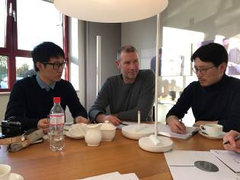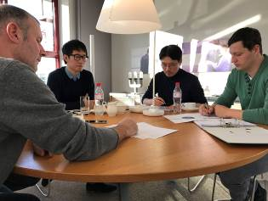
GERA_Kooperation_ GERA_Kooperation_
cooperation_1 cooperation_2

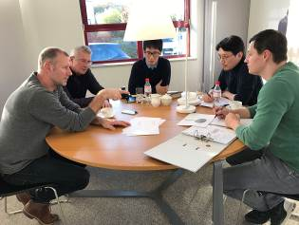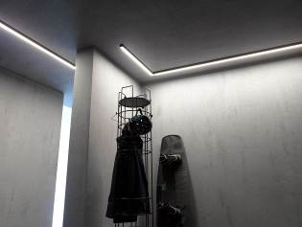
GERA_Kooperation_ GERA_Deckenleuchte_ceilinglight
cooperation_3

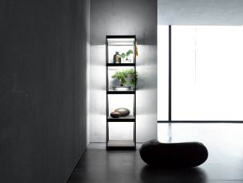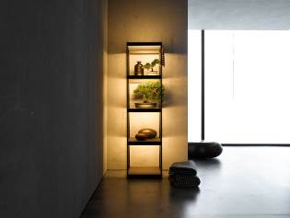
GERA_Q40_1 GERA_Q40_2
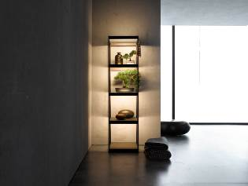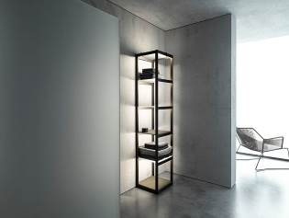
GERA_Q40_3 GERA_Q40_4
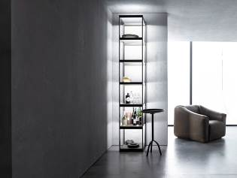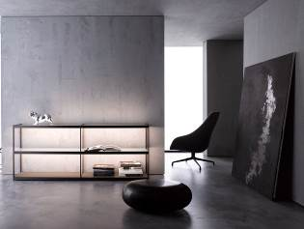
GERA_Q40_5 GERA_Sideboard_1
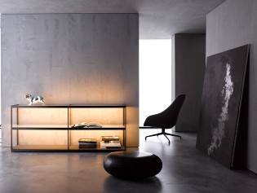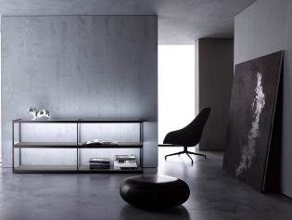
GERA_Sideboard_2 GERA_Sideboard_3
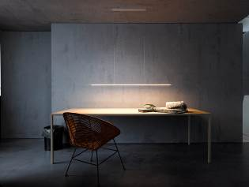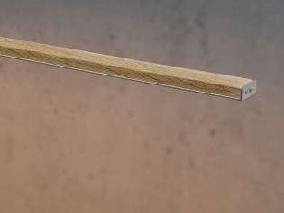
GERA_Pendelleuchte_pendantlight GERA_Pendelleuchte_
20x10_1 pendantlight_20x10_2

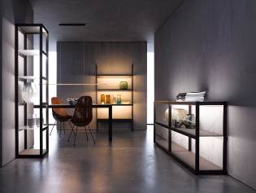
GERA_Lichtmöbel_
lightingfurniture

Caption:
File: GERA_Kooperation_cooperation_1: f.l.t.r.: Haiwei Ye, Thomas Ritt, Jeho Yoon

File: GERA_Kooperation_cooperation_2: f.l.t.r.: Thomas Ritt, Haiwei Ye, Jeho Yoon, Robert Keil

File: GERA_Kooperation_cooperation_3: f.l.t.r.: Thomas Ritt, Hening Pölitz, Haiwei Ye, Jeho Yoon, Robert Keil

