Architecturally impressive lighting concepts:
Successful trade fair display for GERA Leuchten
More visitors than ever before: record visitor numbers at the imm cologne, which finished on 22 January 2017 – and this year's imm cologne was also a success for GERA Leuchten. The display of lighting sources with a furniture function with the trade fair motto "Light carries" attracted much interest from the trade audience as well as the general public on the days when the imm cologne was open to the public. "We have more than achieved our aim for the trade fair," says GERA Leuchten CEO Hening Pölitz. "There is an increased awareness of the GERA Leuchten brand and many people now actually head for our display on purpose."
At its minimalist, elegantly designed imm cologne stand, GERA Leuchten showed how room lighting can be combined with the functional purpose of a piece of furniture. In keeping with the company's product philosophy, the sideboard 100/200, the lighting shelf Q40 and also the pendant light 20/10, a new product shown for the first time at the fair, are all about reduced design: "We exhibited light sources that have been reduced down to the bare minimum. We believe their function is to get the best out of lighting as a design element," says GERA Leuchten product manager and designer Thomas Ritt.
This concept of looking at lighting from an architectural perspective attracted much interest and led to actual orders: "Many visitors headed for our stand on purpose," says Hening Pölitz. "The market is now aware of the fact that we develop lighting that allows furniture designers, for example, to add a new dimension to their designs. We're basically talking about the design dimension of lighting."
GERA Leuchten intends to take the resulting flexibility further in future: alongside the company's current products, it also exhibited a combination of a pendant light and a portable light source which GERA Leuchten developed within the scope of a collaborative project together with university students, for instance: "The prototypes we showed at the imm cologne offer the kind of multi-functionality that meets the needs of how we will live in future," says Thomas Ritt. "As a result of the feedback we received at the fair, we are now considering to further pursue the development of these designs up to the point of being able to market them."

The GERA Leuchten company
On the basis of its comprehensive lighting design, furniture construction and electrical engineering expertise, the GERA Leuchten company, which is based in Thuringia in Germany, develops furniture concepts that are unique and a market first in this combination with the respective lighting technology.
With its characteristic lighting furniture, the company is exploring a totally innovative product category that always has a dual interior design and functional purpose through the combination of lighting with light projection. The design of the individual products is the result of applying the dimensional system of a generic product family. Formal severity, design simplicity, authenticity and logic are brought together to result in products with a style that is characterised by timeless, functional shapes.
All products of course also meet the highest quality standards as they are "Made in Germany". The manufacturing process is ISO certified, and GERA employs only qualified staff.
Overview of image data

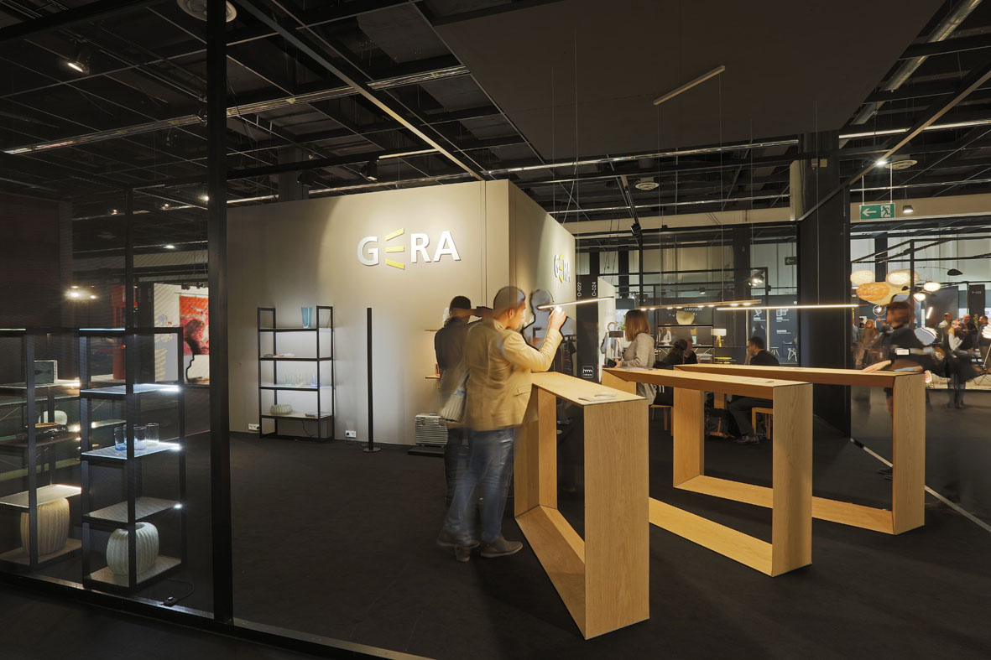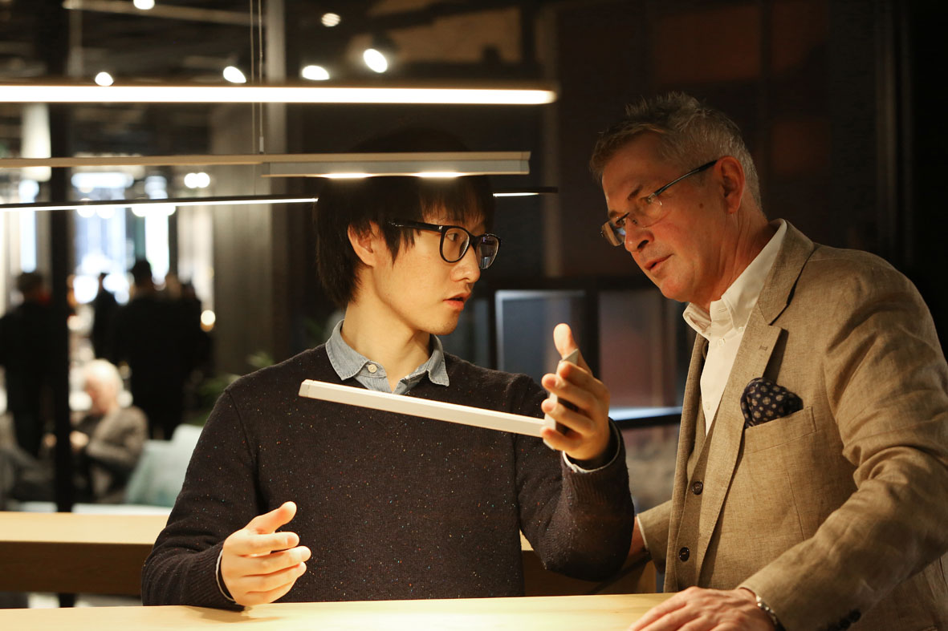
GERA_imm_1 GERA_imm_2
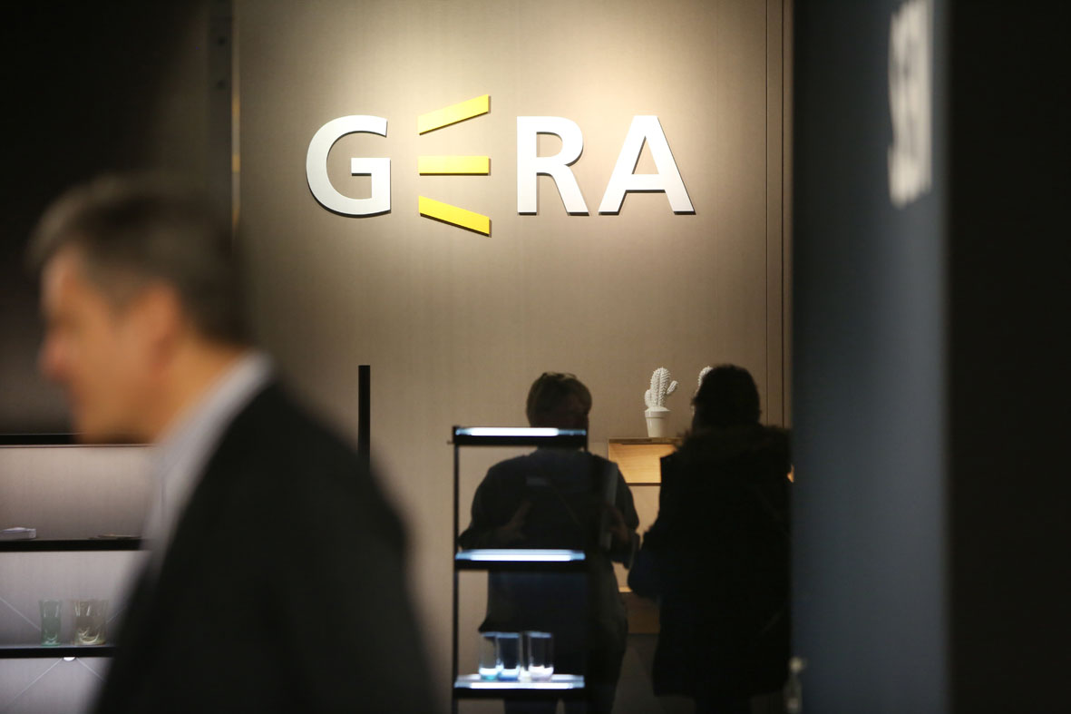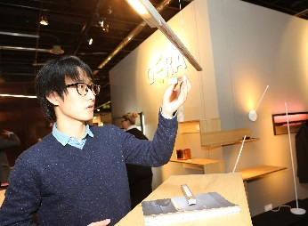
GERA_imm_3 GERA_imm_4

