“Gilded product philosophy”: GERA Leuchten gives a positive trade fair verdict
With more than 69,000 visitors from 152 countries, interzum not only set a new record – it also lived up to its reputation as the world’s leading trade fair for the furniture supplier industry. Hening Pölitz, GERA Leuchten CEO, is very satisfied with how the trade fair went: “We were able to welcome nearly all our customers to our stand and interest many visitors from all over the world in our products.” Apart from the high level of quality, it was the clear design of the lamps and light systems, in particular, that engendered enthusiasm: “Many customers felt reminded of Italian design. We were pleased to hear that, of course – Italy, after all, still sets the standard when it comes to the design of furniture and furniture accessories”, said Hening Pölitz.
In terms of design, the new light system LS2P3, in particular, received thoroughly positive feedback: with its delicate and timeless visual appearance, the system enables a high degree of versatility. It can be used as an under-unit light or wall light, is available in different lengths and colours, can be equipped with sockets or additional accessories for mounting and – when it is used as a wall light – stands out due to its dual support and light functions. In addition, the new spotlights, in particular, were well received by many kitchen manufacturers. Anyone wishing to generate high light quality and a harmonious room/light climate, can now use GERA Leuchten’s first spotlight solution, which can be remote-controlled in groups by means of GERA white adaptation.
“Our new products subscribe to GERA’s basic concept: it is not the lamp itself, but the light that it produces that is the aim of our design endeavours. We want to enable our customers to increase the cosy feel of their furniture products”, says Thomas Ritt, product manager and designer at GERA Leuchten. “We show how this light result can even be used to design spaces – and the effect also formed the link between product presentation and the colour concept of our stand design.” The dominant hue on GERA Leuchten’s stand was in shades of gold. The numerous visitors to interzum were able to witness how this warmly reflective precious metal is illuminated even more strongly in combination with oak and the elegant black-brown light systems. This stand seemed to give the GERA Leuchten brand’s innovative product philosophy a literally gilded appearance.

The GERA Leuchten company
On the basis of its comprehensive lighting design, furniture construction and electrical engineering expertise, the GERA Leuchten company, which is based in Thuringia in Germany, develops furniture concepts that, in combination with the relevant lighting technology, are unique in the market.
With its characteristic lighting furniture, the company is developing a novel product category that always has a dual interior design benefit due to its combination of light and support functions. The design of the individual products is the result of applying the dimensional systematicity of a higher-order product family. Formal rigour, simplicity of design, authenticity and logic combine to form products whose style is characterized by timeless, functional shapes.
All products, of course, also satisfy the highest quality standards, bearing, as they do, the “Made in Germany” seal of quality. The ISO-certified manufacturing process and highly qualified GERA staff also see to this.

Overview of image data

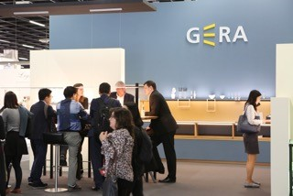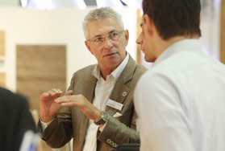
GERA_interzum_1 GERA_interzum_2
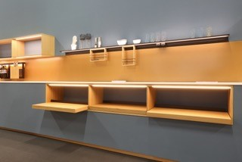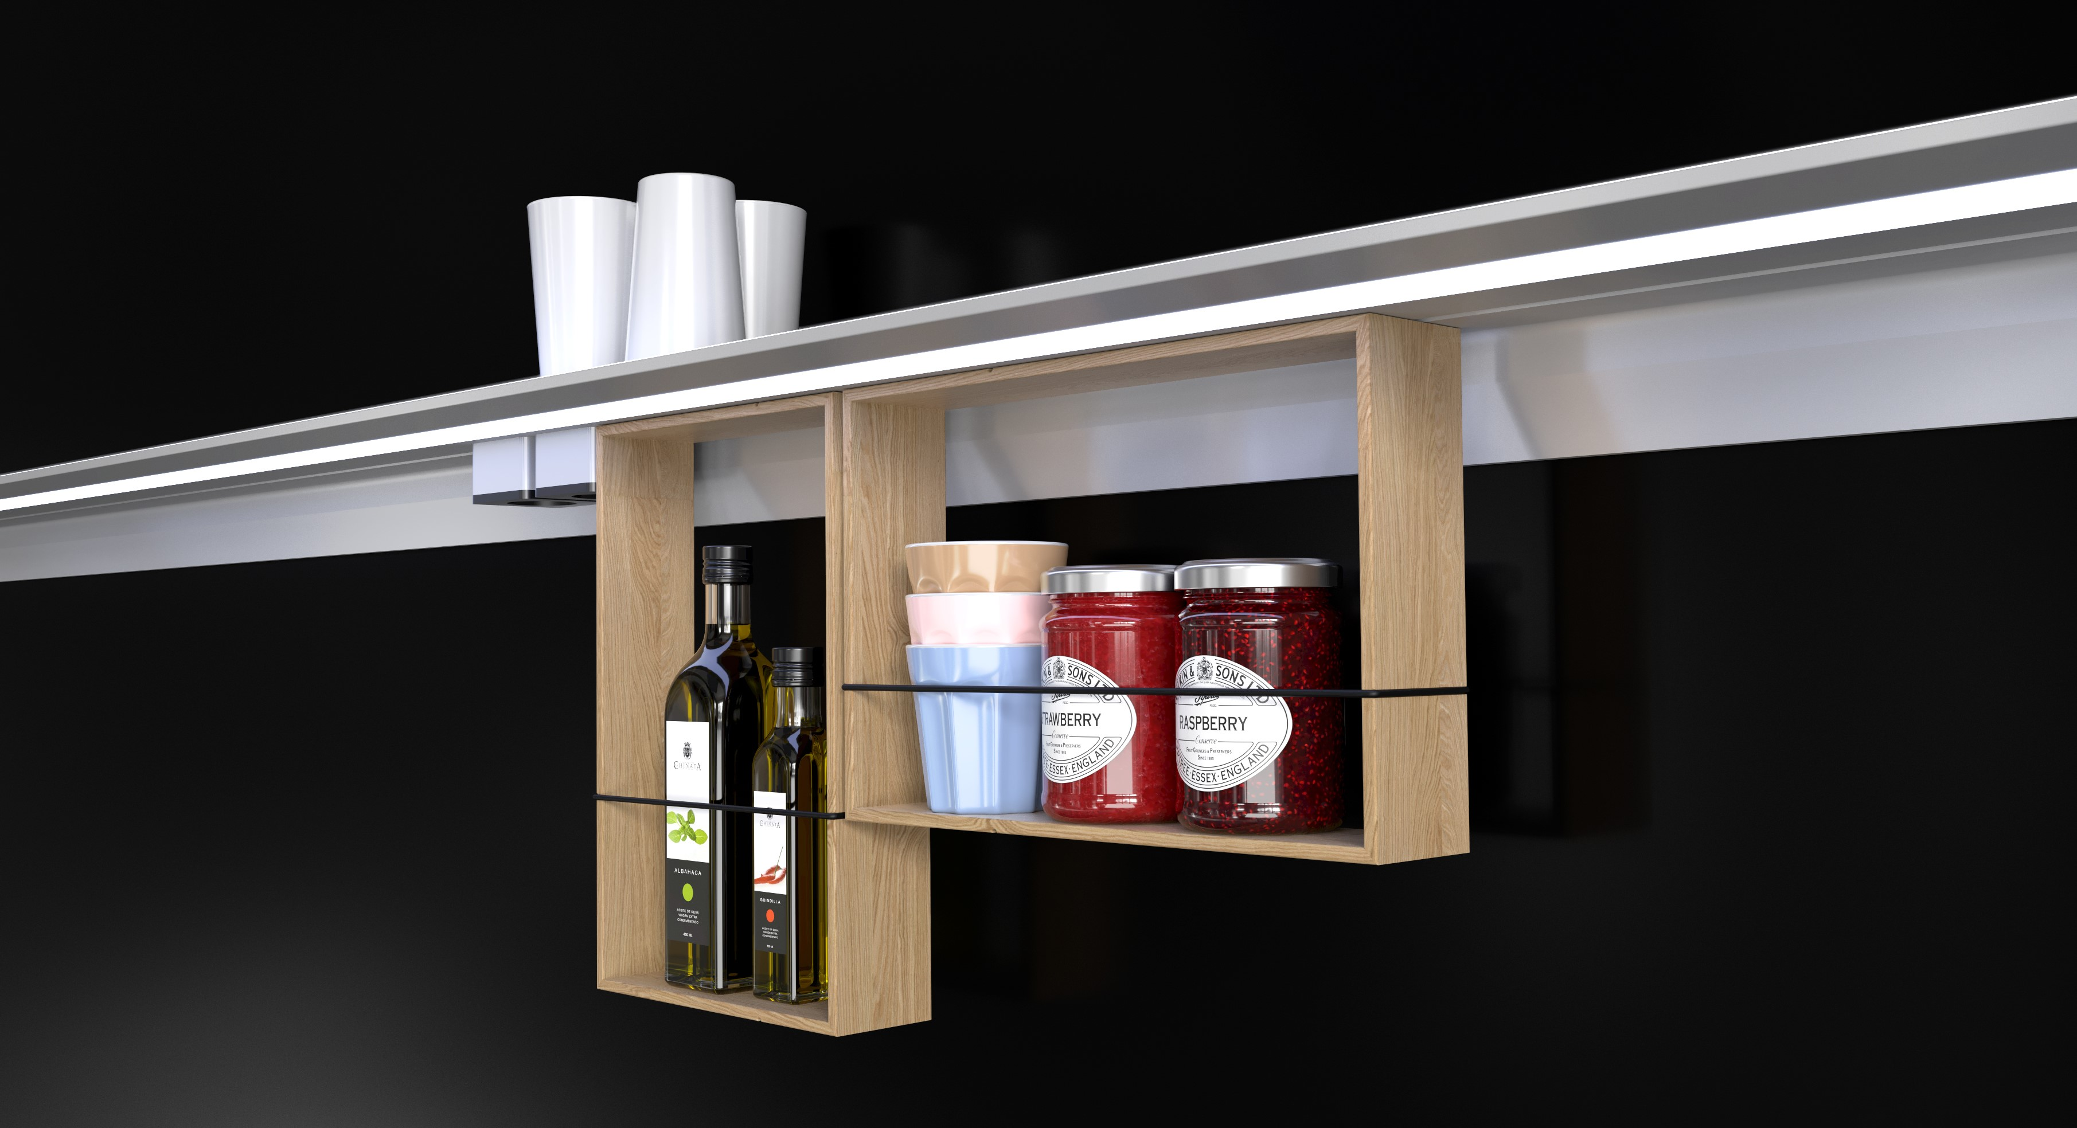
GERA_interzum_3 GERA_LS2P3
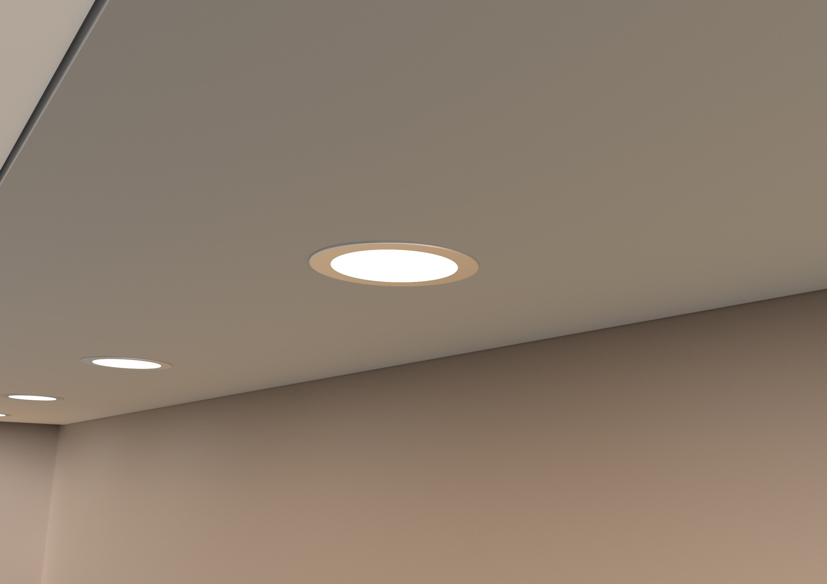
GERA_Spotlights

Image caption:
File: GERA_interzum_1: Heavy visitor traffic to GERA Leuchten’s exhibition stand.

File: GERA_interzum_2: Managing Director Hening Pölitz in discussions.

File: GERA_interzum_3: The new light system LS2P3 as a wall light with matching accessories.

File: GERA_LS2P3: The new light system LS2P3 as a wall light with matching accessories.

File: GERA_Spotlights: GERA Leuchten’s new spotlight solutions.

