Table of Contents
"Lighting that's also a piece of furniture":
GERA Leuchten at the interzum 2019 Page 2-4
The new "LichtBox" and "LichtBank":
Minimalism with maximum effect Page 5-7
Integrated light GLS 4:
Turns the kitchen into a light Page 8-9
Pendant light 10 x 40:
A spaceship has landed Page 10-11
The GERA Leuchten company Page 12-13
Image material Page 14

"Lighting that's also a piece of furniture": GERA Leuchten at the interzum 2019
"We furnish homes – with lighting or lighting furniture," says Hening Pölitz, the owner and CEO of Gera Leuchten when asked to describe the company's approach. Accordingly, the trade fair motto under which GERA Leuchten will be launching all of its various new products at the interzum 2019 is "Lighting that's also furniture".
Minimalism, lighting as a room design element, clear contours: these are the aspects that all of the products in the company's portfolio have in common. The new products also represent a continuation of this design approach. In Cologne, GERA Leuchten will be showing further developments of existing lighting systems, albeit used in a way that seems completely new.
This innovation based on familiar concepts is in line with another GERA Leuchten approach: "We are not only interested in the light as such but ultimately in the lighting result," says designer Thomas Ritt, who is responsible for the design of the GERA Leuchten products. Due to this approach, the products are perfect for realising one of the most important current interior design trends: open plan living, rather than clearly separating the various areas in the home according to their individual functions. Kitchens open out into the living areas; bathrooms move closer to bedrooms. This also changes the lighting requirements. "Our lights and lighting furniture are ideal for realising this trend," says Hening Pölitz. "They can be used individually and are not limited to one particular area in the home."
The new "LichtBox": Minimalism with maximum effect
The new "LichtBox" is based on the minimalist structure of the company's Lighting System 4: a rectangular black aluminium profile frame with integrated LED lights at the front and at the back. The sawn aluminium profiles, which are connected to each other with corner profiles, make the system extremely lightweight; it can therefore be used to great effect anywhere in the home. "We design our products in a way that means they can be used individually, rather than for a particular purpose in a particular area," says Thomas Ritt.
This is also revealed by another characteristic of the "LichtBox": the profiles hold a glass shelf; the "LichtBox" can therefore be used to display and highlight special objects. On the one hand, the extremely bright and indirect lighting lights up the back wall. On the other, the precious objects on display in the "LichtBox" are lit from the front. Whether a vase, a sculpture or a flower arrangement – every object in the box is staged to perfection with the aid of lighting. Just like in the theatre, where lighting usually also comes from the front to draw the attention to what's going on stage. What exactly is to be staged in this way is up to the user's imagination – the "LichtBox" is therefore not only a functional piece of furniture but also like a movie screen with the stars chosen by the user.
The "LichtBox" is wall-mounted – and can therefore be installed overhead in fitted kitchens, where it casts an extremely pleasant, very bright and at the same time quite indirect light on the worktop. The "LichtBox" will be available in the sizes 600 x 350 x 350 and 900 x 350 x 350 mm from the second half of the years onwards.
The "LichtBank" represents an additional further development of Lighting Systems number 4 and 6. It can be installed upright on a kitchen island and is also available as a ceiling light. The shelf consists of a sheet of cut glass that breaks the light upwards and downwards. Kitchen utensils can be stored on the "LichtBank"; other utensils such as whisks, sieves, soup ladles or wooden spoons can also be stored below the shelf. GERA Leuchten will be presenting a prototype of this piece of lighting furniture at the interzum.

Integrated light GLS 4: Turns the kitchen into a light
Another innovation that GERA Leuchten will be introducing at the interzum is also based on Lighting System 4: the dimmed integrated light GLS 4. The light, which measures 20 x 10 cm, is designed to be fitted to or inset into furniture in a linear way. This results in an almost flush fitting light, for example for the inside of a cabinet. In contrast to most of the usually available solutions, the lighting provided by integrated light GLS 4 is directed only inwards. "The lighting system is a perfect example of the fact that we are not only interested in the light as such but in the lighting result," says Thomas Ritt. "In this case, the result is that that the lighting is directed towards objects, rather than towards the user's eyes."
The lighting mood is variable. The user decides via remote control whether the inside of the cabinet is lit up in warm or cool shades. Lighting control is essential, especially with regard to decors and different surface finishes. Certain surface finishes like concrete, for example, call for cool lighting, whilst others come into their own under warmer lighting. "This integrated light illustrates one of our objectives," says Hening Pölitz: "It is not the light source provides the lighting; the kitchen itself becomes the light."

Pendant light 10 x 40: A spaceship has landed
The simplest ideas are sometimes the most brilliant. This realisation definitely applies to the new pendant light 10 x 40. It is based on Lighting System 6 and is already on offer in a 40 x 10 cm version. The new pendant light is based on a simple idea. The already existing light was simply turned upside down. The light emerges only from the narrow upper and lower edges. This creates a unique effect that makes the light look a little bit like a landing spaceship. This minimal change with maximum effect is another clear statement with regard to GERA Leuchten's product philosophy: "You don't have to invent new benchmarks. You have to consistently apply minimalism. That is the goal, if you work the way we do. Totally simple, totally easy, totally consistent," explains Thomas Ritt.

The GERA Leuchten company
On the basis of its comprehensive lighting design, furniture construction and electrical engineering expertise, the GERA Leuchten company, which is based in Thuringia in Germany, develops furniture concepts that are unique and a market first in this combination with the respective lighting
technology.
With its characteristic lighting furniture, the company is exploring a totally innovative product category that always has a dual interior design and functional purpose through the combination of lighting with light projection. The design of the individual products is the result of the dimensional system of a generic product family. Formal severity, design simplicity, authenticity and logic are brought together to create products with a style that is characterised by timeless, functional
designs.
Of course, all products also meet the highest quality standards as they are "made in Germany". The manufacturing process is ISO certified, and GERA employs only qualified staff.

Image material

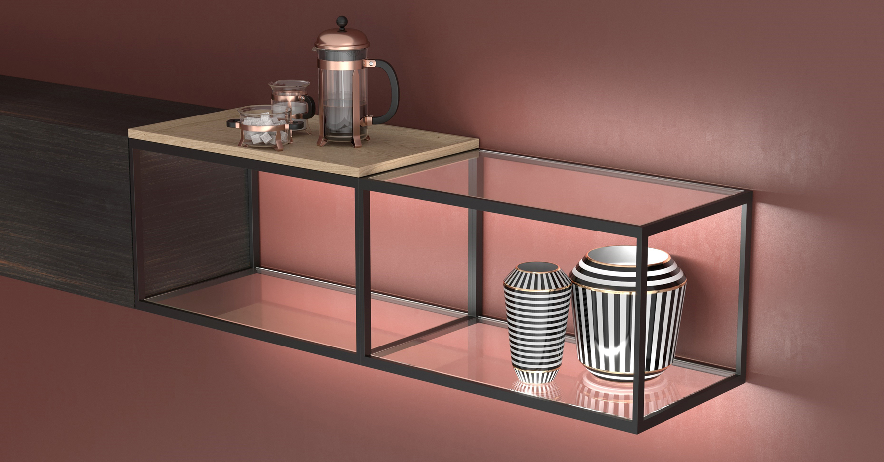
GERA_LichtBox_GLS4

Caption:
File: GERA_LS4_Kueche_kitchen: At the interzum, GERA Leuchten will also be showing lighting systems that can be used individually in room designs, for example.

Note:
You can download images of the new products after the interzum from m.weller@goos-communication.com.

