Successful interzum 2019 for GERA Leuchten
As the leading trade fair, interzum is of enormous significance for furniture suppliers and manufacturers. And also in 2019, it lived up to its reputation as the central event of the industry: About 74,000 visitors from 152 countries were counted. Participating in the trade fair has been a great success for GERA Leuchten as well: The lighting specialist from St. Gangloff from Thuringia only showed new products on its minimalistic stand.
“We were able to welcome a total of about 250 visitors at our stand,” said Hening Pölitz, owner and managing director of GERA Leuchten. True to their motto “Furnishing with light”, the new light box and light bridge, in particular, were the centre of the display and attracted a lot of attention.
The light box structure which has been reduced to the essential and is based on the lighting system 4 produces a maximum effect. The rectangular frame, which has LED lights integrated in the top and bottom on the inside of its black aluminium profile, blends into any part of the apartment discreetly while still making a statement. “The special feature of the light box is its filigree work, its compatibility with the GERA lighting system 4 and its versatile application. It is not limited to specific functional areas,” said GERA Leuchten product designer Thomas Ritt. “This means that the Box meets one of the consumers’ key desires: the fusion of different living areas.” The prototype of the light bridge was also well received by trade fair visitors. The system can either be fitted to a cooking island in a standing position or even attached to the ceiling above it. Here the lit glass surfaces serve as lighting and as a presentation area, for example, for spices or even pots of herbs. The latter can also be placed under the light – with up to 6,000 Kelvin this can even boost the growth of the plants. Especially with regard to the current trend of kitchen gardening, the lighting system is a smart solution to combine light and function in a meaningful way. “The feedback relating to our products was very positive in all aspects,” according to Hening Pölitz. “Their versatility adds value to all rooms and combines that which was previously separated.”
This gentle, elegant transition is reflected in the design of the stand of GERA Leuchten in Hall 4.2. The company’s product philosophy places the focus on light: it is not the lamp that is in focus, but the light it gives off. The key phrase is: “Furnishing with light.” This philosophy of integration and reduction could also be found in the stand design which placed the light solutions from GERA at the centre. This created an atmosphere that immediately pulled visitors into its orbit – coming from the glaring trade fair lighting, the display of GERA Leuchten was akin to a place for contemplation.

The GERA Leuchten company
On the basis of its comprehensive lighting design, furniture construction and electrical engineering expertise, the GERA Leuchten company, which is based in Thuringia in Germany, develops furniture concepts that are unique and a market first in this combination with the respective lighting
technology.
With its characteristic lighting furniture, the company is exploring a totally innovative product category that always has a dual interior design and functional purpose through the combination of lighting with light projection. The design of the individual products is the result of the dimensional system of a generic product family. Formal severity, design simplicity, authenticity and logic are brought together to create products with a style that is characterised by timeless, functional
designs.
Of course, all products also meet the highest quality standards as they are "made in Germany". The manufacturing process is ISO certified, and GERA employs only qualified staff.
As overview of photo data

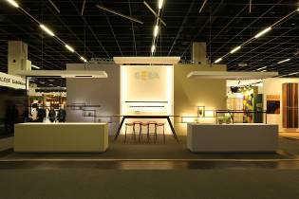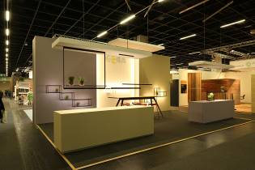
GERA_exhibition_stand_ GERA_exhibition_stand_ interzum_1 interzum_2

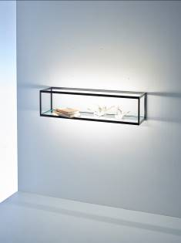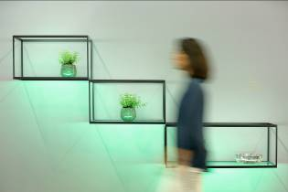
GERA_Lightbox _23x23x90 GERA_exhibition_stand_Lightbox

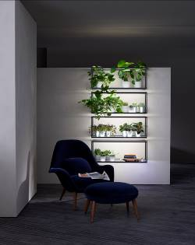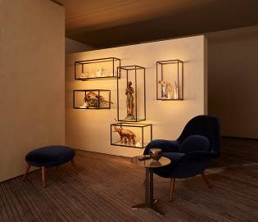
GERA_Lightbox_Ambiente_1 GERA_Lightbox_Ambiente_2
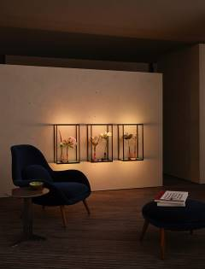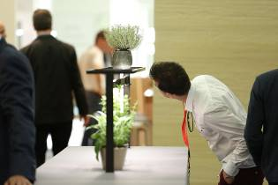
GERA_Lightbox_vertical GERA_exhibition_stand_
Lightbridge

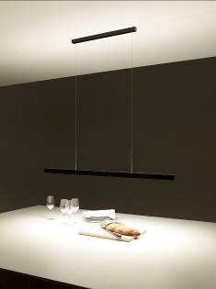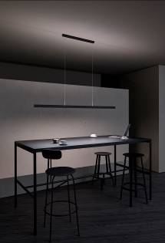
GERA_Pendant light 10x40_1 GERA_Pendant light 10x40_2

Picture captions:
File: GERA_exhibition_stand_interzum_1: The philosophy of integration and reduction was also taken up by GERA Leuchten in the stand design, where the lighting solutions of GERA were placed in the centre.

File: GERA_exhibition_booth_interzum_2: GERA Leuchten presented exclusively new products on the minimalistic designed booth.

File: GERA_Lightbox _23x23x90: The new lightbox is based on the minimalistic structure of the light system 4.

File: GERA_exhibition_stand_Lightbox: The new lightbox - minimalism with maximum effect. Here in green light - the light colour can be adjusted by remote control.

File: GERA_Lightbox_Ambiente_1: The new lightbox from GERA
Leuchten: A rectangular frame, in whose black aluminium profiles front and rear LED lights are integrated.

File: GERA_Lichtbox_Ambiente_2: The profiles of the lightbox contain a glass bottom. This serves as a shelf and makes it possible to use the light box to stage various objects.

File: GERA_Lightbox_vertical: The LightBox can be used to stage different objects.

File: GERA_exhibition_stand_Lightbridge: Visitors to the prototype of the light bridge.

File: GERA_Pendant light 10x40_1: The new pendant light 10 x 40 cm with light emission from the narrow upper and lower edge.

File: GERA_Pendant light 10x40_2: The new 10 x 40 cm pendant light is a further development of the 40 x 10 cm pendant light.

