Lighting that's also a piece of furniture: Perfect start to the new furnishing year 2018 for GERA Leuchten

From the perspective of the exhibitors from almost 140 countries, this year's imm cologne was a resounding success. Top trade and industry decision- makers and also the many interested visitors who visited the show on the ﬁnal weekend, when it is open to the public, made good use of the opportunity to experience the latest furnishing and interior design trends live from 15 to 21 January 2018. This year's key themes were smart home, bathrooms – and lighting.

GERA Leuchten CEO Hening Pölitz really enjoyed meeting the knowledgeable trade and industry visitors and representative from popular trend and home magazines: "We were able to welcome an unusually broad spectrum of visitors with diﬀerent backgrounds at our stand who were extremely interested in our products. The imm cologne is a very special opportunity for presenting our product portfolio to new and existing customers in a trade show environment."

It soon became obvious which product from Thuringia-based company's product portfolio was the most popular with the visitors to the stand in Hall 2.2.: The lighting system 2P3, which was launched at the trade show in Cologne, impressed everyone with its high-quality ﬁnish, unusual ﬂexibility and timeless design. The extremely ﬂat, wall-mounted proﬁle can be used as under-cabinet lighting as well as wall-mounted and is available in various lengths and ﬁnishes. When wall-mounted, the LED lights point upwards and downwards; the two

circuits can be controlled separately. "GERA's lighting system 2P3 can also be equipped with power points, USB ports and practical accessory holders as required. The proﬁle is therefore also a kitchen, bathroom and hallways accessory organiser, which is totally in keeping with our product philosophy of creating lighting that's also a piece of furniture," says GERA Leuchten product manager and freelance designer Thomas Ritt, adding: "Our design eﬀorts do not focus on the light as such but on the resultant lighting. We want to oﬀer our customers various possibilities for improving the atmosphere in their homes with lighting and at the same time make the light source multi- functional."

Further examples of this innovative design approach were on display at the GERA stand at the imm cologne: The company's sideboards, which are set to become a design classic, the wall shelf 100, the ﬂoor lamp Avion and also its popular pendant lights. The lighting shelf Q40, which GERA Leuchten launched successfully last year – a compact version from its design award winning collection of lighting shelves – and takes up a ﬂoor space of only 40 by 40 centimeters also attracted much attention.

The GERA Leuchten company

With its comprehensive know-how concerning light design, furniture construction and electrical engineering, the Thüringen company GERA Leuchten develops furniture concepts which, combined with their appropriate light technology, are unique on the market.

Furnishing with light is the product philosophy behind the brand. With its characteristic light furniture, the company is opening up an innovative new product category due to which an interior architectural double beneﬁt is oﬀered through the linking of illumination and load-bearing functions. The design of the individual products arises from the dimensional system of a superordinate product family. Formal strictness, design simplicity, authenticity and logic unite to form products, the style of which is characterised by timeless, functional shapes.

All our products fulﬁl the highest quality standards and bear the quality seal Made in Germany. This is ensured by the ISO-certiﬁed manufacturing process and our high-quality GERA employees.

Press pictures imm cologne 2018

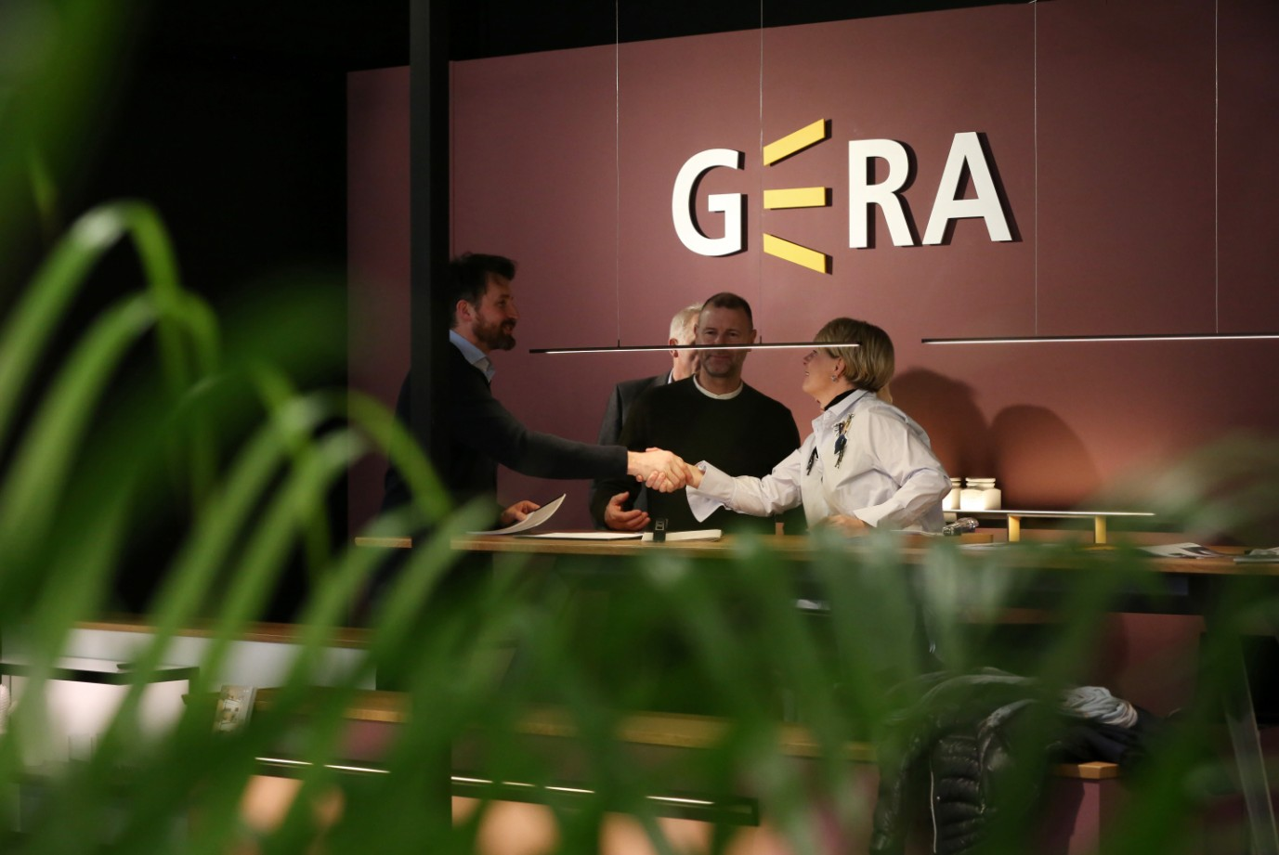

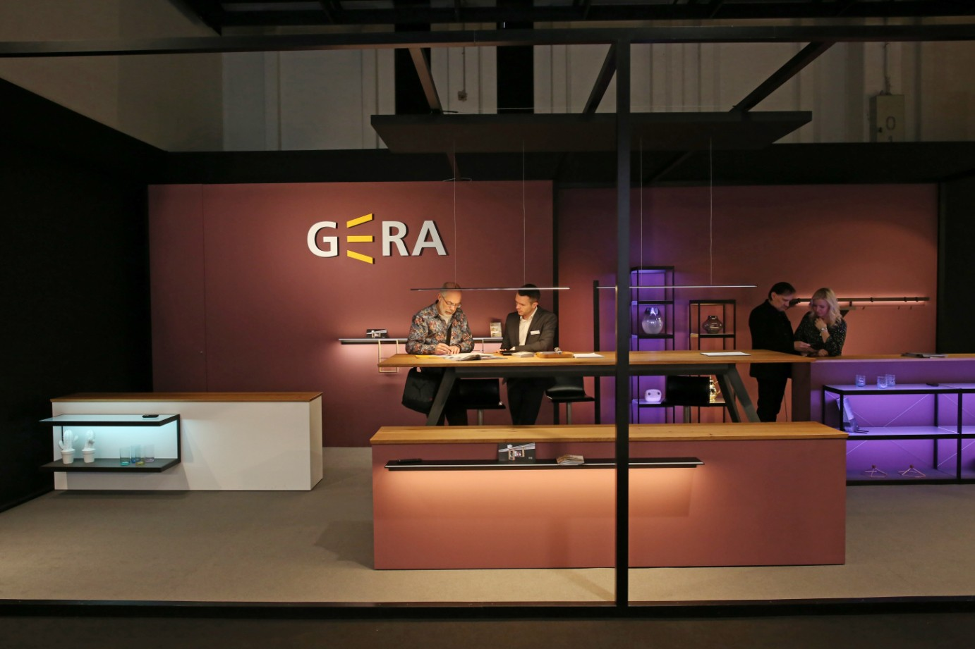

GERA_imm_2018_1 GERA_imm_2018_2

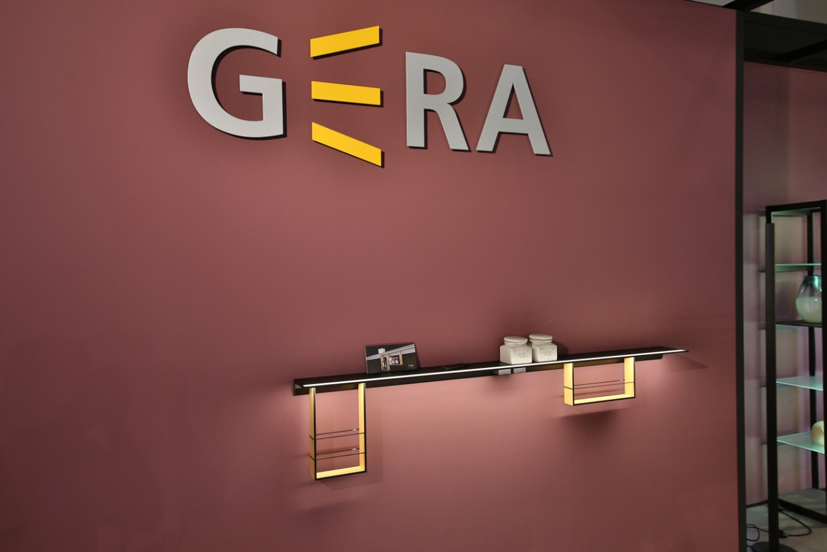

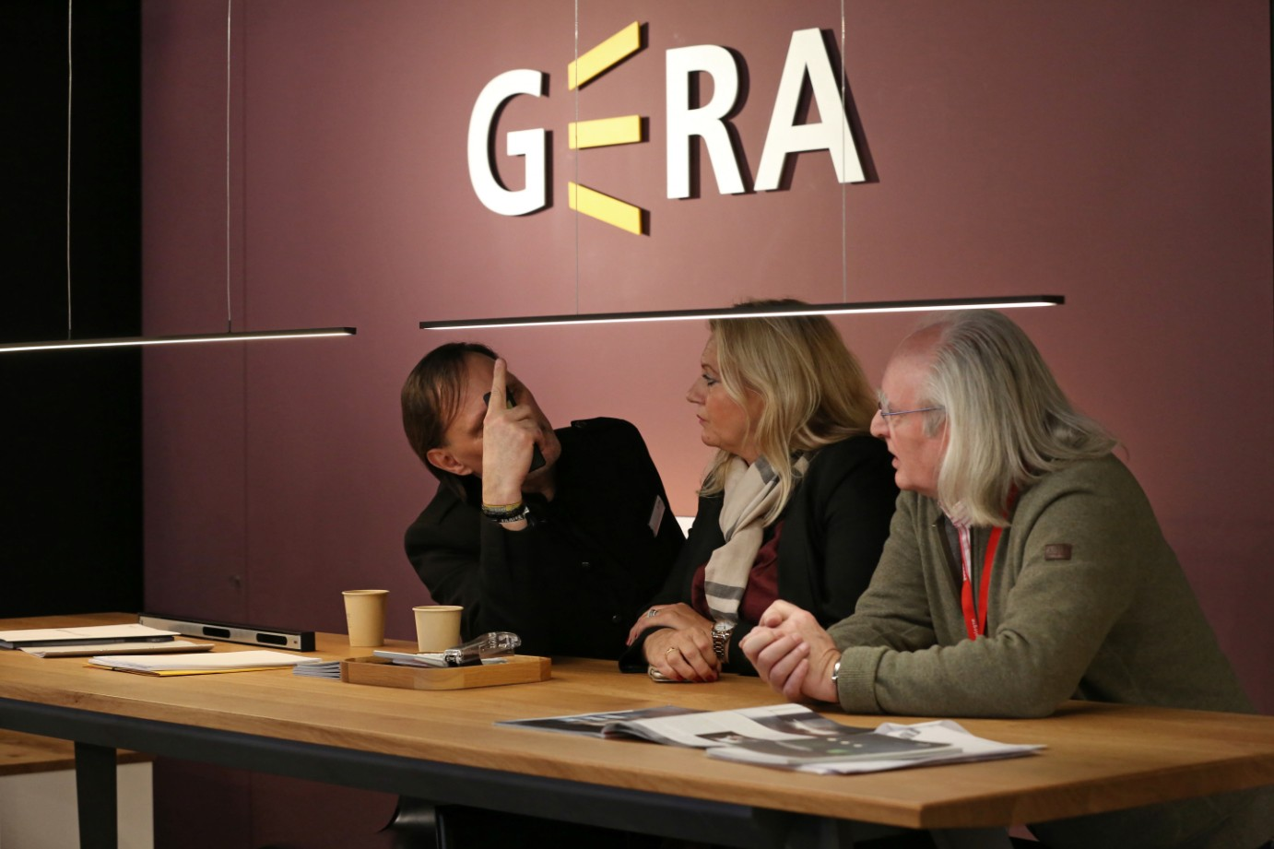

GERA_imm_2018_3 GERA_imm_2018_4

